Robert S. Bruer*
Brian L. Shepard**

Chapter 21

Use of an Expert in Proving Damages

I. Introduction

A. (§21.1) Importance of Experts in Proving Damages
B. (§21.2) Scope of Chapter
C. Legal Principles Applicable to Experts
1. Discovery
a. (§21.3) Independent Medical Examination
b. (§21.4) Physician-Patient Privilege
c. (§21.5) Expert Documents
d. (§21.6) Depositions
e. (§21.7) Supplementation
2. Trial
a. (§21.8) Use of Medical Records
b. Use of Medical Literature
(1) (§21.9) Direct Examination
(2) (§21.10) Cross-Examination
c. (§21.11) Medical Bills
d. (§21.12) Causation
e. (§21.13) The “Rule” Excluding Witnesses
3. Particular Cases
a. (§21.14) Class Actions
b. (§21.15) Undue Influence
c. Medical Malpractice
(1) (§21.16) Health Care Affidavit
(2) (§21.17) Future Damages
(3) (§21.18) Res Ipsa Loquitur
Authors: Please double check your bio information.

Thank you.

______
*Mr. Bruer received his J.D., 1995, from the University of Missouri School of Law. He is a shareholder in the firm of Bruer, Wooddell & Harrell, P.C. in Kansas City.
**Mr. Shepard received his J.D., 2010, from the University of Missouri-Kansas City School of Law. He is an associate in the firm of Bruer, Wooddell & Harrell, P.C. in Springfield.

This chapter includes material previously prepared by John D. Wooddell and Jeffrey W. Bates.

II. Experts Used in Personal Injury and Death Cases

A. (§21.19) Economist
B. (§21.20) Medical Doctor
1. (§21.21) Proof of the Cause, Nature, and Extent of Plaintiff’s Injuries
2. (§21.22) Proof of Economic Loss
3. (§21.23) Visual Aids
C. Nurse
1. (§21.24) Nurse as Expert Witness
2. (§21.25) Nurse as Skilled Witness
D. (§21.26) Psychologist
1. (§21.27) Psychologist’s Role
2. (§21.28) Visual Aids
E. (§21.29) Vocational Rehabilitation Expert
F. (§21.30) Rehabilitation Engineer
G. (§21.31) “Special Needs” Experts
1. (§21.32) Computer Assistance and Communications
2. (§21.33) Home Modifications
3. (§21.34) Mobility Aids
H. (§21.35) Therapist
I. (§21.36) Trial Judge

III. Effective Use of an Economist

A. (§21.37) Caselaw Guidelines for Using an Economist
B. (§21.38) Selecting the Economic Expert
C. (§21.39) Items of Damages to Be Calculated
1. (§21.40) Lost Earnings
2. (§21.41) Lost Household Contributions
3. (§21.42) Cost of Medical Care, Equipment, and Supplies
4. (§21.43) Unique Wrongful Death Statutory Damages
D. Preparing the Economist
1. (§21.44) Information Supplied
a. (§21.45) Vital Statistics
b. (§21.46) Employment and Earnings History
c. (§21.47) Household Contribution History
d. (§21.48) Disability Information or Assumptions
e. (§21.49) Unit Costs of Medical Care, Equipment, and Supplies
2. (§21.50) Preparing to Testify
E. Calculations
1. Lost Earnings
a. (§21.51) “Past” and “Future” Losses
b. (§21.52) Fringe Benefits
c. (§21.53) Retirement Age
d. (§21.54) Growth Rate
e. (§21.55) Discount Rate
f. (§21.56) “Nominal” Versus “Real” Figures in Establishing Growth and Discount Rates
g. (§21.57) General Statistics in the Absence of Adequate Personal History
h. (§21.58) Taxes
i. (§21.59) Consumption Allowance in Death Cases
2. Lost Household Contributions
a. (§21.60) “Past” and “Future” Losses
b. (§21.61) Valuation
3. Cost of Medical Care, Equipment, and Supplies
a. (§21.62) “Past” and “Future” Losses
b. (§21.63) Growth and Discount
4. Life Expectancy
a. (§21.64) In General
b. (§21.65) Caselaw Guidelines
c. (§21.66) Available Tables
5. (§21.67) Disability Percentages
F. Communicating the Calculations
1. (§21.68) In General
2. (§21.69) Visual Aids
a. (§21.70) Summary Chart
b. (§21.71) Explanatory Charts or Transparencies
(1) (§21.72) Vital Statistics
(2) (§21.73) Earnings History
(3) (§21.74) Lost Earnings Calculations
(4) (§21.75) Lost Household Contribution Calculations
(5) (§21.76) Medical Care Calculations
3. (§21.77) Placing Calculations in Perspective

IV. (§21.78) Damages Experts in Property Damage and Commercial Loss Cases

A. (§21.79) Damage to Personal Property
B. (§21.80) Damage to Real Estate
C. (§21.81) Commercial Loss Cases
D. (§21.82) Domestic Cases

V. Illustrative Visual Aids

A. (§21.83) Figure 1—Equipment Used in John Smith’s Treatment
B. (§21.84) Figure 2—Hospital Complications Record
C. (§21.85) Figure 3—Laboratory Tests—John Smith
D. (§21.86) Figure 4—John Smith’s Urinary Tract Infections
E. (§21.87) Figure 5—John Smith’s Medications
F. (§21.88) Figure 6—Table of Scaled Score Equivalents (1979)
G. (§21.89) Figure 7—Table of Scaled Score Equivalents (1981)

H. (§21.90) Figure 8—Table of Scaled Score Equivalents
(Comparison of 1979 and 1981)
I. (§21.91) Figure 9—John Smith—Vital Statistics
J. (§21.92) Figure 10—John Smith’s Earnings History
K. (§21.93) Figure 11—Calculation—Past Lost Earnings
L. (§21.94) Figure 12—United States Historic Growth and
Discount Rates
M. (§21.95) Figure 13—Average Earnings—Male High School
Graduates
N. (§21.96) Figure 14—Calculation—Future Lost Earnings

O. (§21.97) Figure 15—Examples of Hourly Costs of Household
Contributions
P. (§21.98) Figure 16—Medical Inflation Rates (1953–1985)
Q (§21.99) Figure 17—Medical Care Calculation
R. (§21.100) Figure 18—Items Not Considered in Calculating
John Smith’s Economic Loss

I. Introduction

A. (§21.1) Importance of Experts in Proving Damages

Economists, psychologists, and rehabilitation experts are sometimes as necessary as the treating physician in the presentation of damages evidence. The use of these and other damage experts permits innovative presentations that bring home to the jury the seriousness of the damages that have been incurred.

For instance, in Benedict v. Northern Pipeline Construction, 44 S.W.3d 410, 429 (Mo. App. W.D. 2001), the plaintiff was injured when she fell into a sinkhole caused by the defendant’s construction and fractured her coccyx. The jury awarded her $275,000 in damages. On appeal, the defendant contended that the award was obviously excessive because the plaintiff’s medical bills were only $5,000. In affirming the judgment, however, the Western District noted that the plaintiff presented:
- expert medical testimony that there was no real treatment available to further improve the pain and disability associated with her coccyx injury; and
- expert economic testimony that she sustained approximately $450,000 in lost wages and household contributions.
This evidence was sufficient to support the plaintiff’s judgment.
Two developments in the law make expert witnesses on damages even more important. First, the 2005 medical malpractice statutes place a cap on “noneconomic” damages in medical malpractice cases. See § 538.210, RSMo Supp. 2011. Secondly, 1987 legislation reinstated the doctrine of remittitur. See § 537.068, RSMo 2000. In light of these changes, the careful development of economic losses through expert testimony takes on added significance.

B. (§21.2) Scope of Chapter

This chapter is intended to provide an overview of the types of experts who may be used on issues related to the amount of damages. The emphasis is on personal injury and wrongful death cases, with only a brief discussion of property damage and commercial loss cases. Because it is the plaintiff who has the burden of proving the amount of damage, it is generally the plaintiff who is inclined to call experts on that issue. Accordingly, the materials contained in this chapter may be most useful from the plaintiff’s perspective. On the other hand, defense counsel is finding it increasingly advantageous to call experts to rebut a plaintiff’s claim of damages. The suggestions set out here may at least provide the starting point for the defendant’s approach to damages experts.

In this chapter, the discussion of how to use a damages expert proceeds on the assumption that such testimony is generally admissible, but on some occasions, it may be appropriate to object to proffered evidence on the ground that it does not meet the standard for admission of expert testimony. See, e.g., Schumann v. Mo. Highway & Transp. Comm’n, 912 S.W.2d 548, 553–55 (Mo. App. W.D. 1995) (reviewing whether expert economic testimony quantifying lost enjoyment of life under a “hedonic damages” analysis was properly admitted). Although a comprehensive discussion of the subject is beyond the scope of this chapter, it is appropriate to review some of the basic principles involved.

In federal court, the admission of expert testimony is governed by Federal Rule of Evidence 702. In Daubert v. Merrell Dow Pharmaceuticals, Inc., 509 U.S. 579 (1993), the U.S. Supreme Court held that it is a trial judge’s duty to screen expert testimony for relevance and reliability. Id. at 589. Expert testimony is admissible if it is scientifically based and will assist the trier of fact in determining a fact in issue. In assessing the reliability of expert testimony, a trial judge should consider:

- whether the concept has been tested;
- whether the concept is subject to peer review;
- what the known rate of error is; and
- whether the concept is generally accepted by the community.

Id. Daubert superseded the standard previously followed in federal court, which was set out in Frye v. United States, 293 F. 1013 (D.C. Cir. 1923). Frye held that “while courts will go a long way in admitting expert testimony deduced from a well-recognized scientific principle or discovery, the thing from which the deduction is made must be sufficiently established to have gained general acceptance in the particular field in which it belongs.” Id. at 1014. In Daubert, 509 U.S. 579, the Supreme Court held that the adoption of Rule 702 superseded Frye because its “general acceptance” standard was incompatible with the Federal Rules of Evidence. Daubert, 509 U.S. at 588–89.

In 1989, the Missouri General Assembly passed § 490.065, now RSMo 2000, which only applies to civil actions. Missouri has not adopted the Federal Rules of Evidence, but § 490.065 is partially modeled after Federal Rule of Evidence 702.

Several Missouri decisions have discussed the applicability of and relationship between the Missouri statute and the federal cases. See, e.g., McReynolds v. Mindrup, 108 S.W.3d 662 (Mo. App. W.D. 2002).

The Supreme Court of Missouri has now made it clear that to the extent any Missouri cases have suggested that the standard of admissibility of expert testimony in civil cases is that set forth in Frye, 293 F. 1013, or some other standard, they are no longer to be followed. State Bd. of Registration for Healing Arts v. McDonagh, 123 S.W.3d 146, 153 (Mo. banc 2003). The relevant standard is that set out in § 490.065. McDonagh, 123 S.W.3d at 153.

Following McDonagh, neither Frye, 293 F. 1013, nor Daubert, 509 U.S. 579, governs the admissibility of expert testimony in Missouri civil cases—§ 490.065 is controlling. McGuire v. Seltsam, 138 S.W.3d 718, 720 n.3 (Mo. banc 2004).

C. Legal Principles Applicable to Experts

1. Discovery

a. (§21.3) Independent Medical Examination

Recording an independent medical examination for the purposes of cross-examination of the doctor is inconsistent with the underlying purpose of Rule 60.01. Ratcliff v. Sprint Mo., Inc., 261 S.W.3d 534, 552 (Mo. App. W.D. 2008).

b. (§21.4) Physician-Patient Privilege

A person claiming emotional distress damages is protected by the physician-patient privilege when the claim:
- is only for such emotional distress and humiliation that an ordinary person would experience under the circumstances or that may be inferred from the circumstances; and
- is not supported by any evidence of medical or psychological treatment for a diagnosable condition.
State ex rel. Dean v. Cunningham, 182 S.W.3d 561, 569 (Mo. banc 2006).

c. (§21.5) Expert Documents

Although an expert may be in direct possession of certain documents, the party retaining the expert has the practical ability to obtain those documents from the retained expert for the purpose of a request for production of documents under Rule 58.01(a). See Hancock v. Shook, 100 S.W.3d 786, 797 (Mo. banc 2003). A court may abuse its discretion, however, in requiring a nonparty, such as a hospital, to produce medical records authored by a party’s medical expert. See State ex rel. Williams v. Lohmar, 162 S.W.3d 131 (Mo. App. E.D. 2005).

d. (§21.6) Depositions

“Rule 61.01 does not . . . authorize sanctions against a party for failing, in response to a notice to take depositions, to produce a non-resident, non-retained expert for his deposition in [the] state [of Missouri].” State ex rel. Common v. Darnold, 120 S.W.3d 788, 791 (Mo. App. S.D. 2003).
The discovery rules do not impose a requirement that a party make a nonretained expert available for a deposition. Beaty v. St. Luke’s Hosp. of Kansas City, 298 S.W.3d 554, 559 (Mo. App. W.D. 2009).

e. (§21.7) Supplementation

With respect to the admissibility of expert opinions, parties sometimes object to an expert’s trial testimony on the ground that the opposing party did not supplement the expert’s deposition testimony. For discussions of the supplementation requirement, see:

- Redel v. Capital Region Med. Ctr., 165 S.W.3d 168, 175 (Mo. App. E.D. 2005)

- Sherar v. Zipper, 98 S.W.3d 628 (Mo. App. W.D. 2003)

- Whitted v. Healthline Mgmt., Inc., 90 S.W.3d 470 (Mo. App. E.D. 2002)

2. Trial

a. (§21.8) Use of Medical Records

When a trial court allows a medical record to be referred to and read on the basis of § 490.065.3, RSMo 2000, because the record was used as support for expert opinion testimony, the admission of the record is not error. Klotz v. St. Anthony’s Med. Ctr., 311 S.W.3d at 752, 764–65 (Mo. banc 2010). Section 490.065.3 provides:

3. The facts or data in a particular case upon which an expert bases an opinion or inference may be those perceived by or made known to him at or before the hearing and must be of a type reasonably relied upon by experts in the field in forming opinions or inferences upon the subject and must be otherwise reasonably reliable.

See also Klotz, 311 S.W.3d at 764–65. The purpose of the “facts or data” prong of the statute was to bring the legal practice in line with the standard practice exercised by experts in their respective fields. Id. “Medical experts are allowed to ‘rely on information and opinions of others provided that those sources are not offered as independent substantive evidence, but rather serve only as a background for his opinion.’” Id. at 765 (quoting Lauck v. Price, 289 S.W.3d 694, 699 (Mo. App. E.D. 2009)). “Medical records are the quintessential example of the type of facts or data reasonably relied upon by experts in the field of medicine.” Id. (quoting Glidewell v. S.C. Mgmt., Inc., 923 S.W.2d 940, 951 (Mo. App. S.D. 1996)); see also Lauck, 289 S.W.3d 694.

b. Use of Medical Literature

(1) (§21.9) Direct Examination

When an expert testifies on direct examination about a published study, even if the study is hearsay, Missouri common and statutory law does not prohibit an expert from relying on it as background for the expert’s opinion. Byers v. Cheng, 238 S.W.3d 717, 729 (Mo. App. E.D. 2007). An expert may testify to an opinion based on the expert’s personal experience, from the results stated
in medical literature, or from information learned at professional seminars or courses of study. Id. Missouri caselaw recognized this rule before the enactment of § 490.065, RSMo 2000. Id. Section 490.065.3 does not prohibit an expert from relying on hearsay; rather, that statute recognizes the generally accepted principle that an expert necessarily acquires the expert’s knowledge and expertise from many sources, some of which are inadmissible hearsay. Id. Merely because an expert relied on information and opinions of others does not automatically disqualify the expert’s testimony. Id. As long as these sources serve only as a background for the expert’s opinion and are not offered as independent substantive evidence, the expert should not be precluded from testifying. Id.

Trial courts have discretion to allow or disallow requests to take to the jury room those exhibits that have been properly admitted in evidence. Lunn v. Anderson, 302 S.W.3d 180, 194 (Mo. App. E.D. 2009). This discretion may be invoked even for medical articles admitted in evidence merely to illustrate or explain the testimony of expert witnesses. Id. at 194.

(2) (§20.10) Cross-Examination

In order to use written material to cross-examine an expert, the propounding party must establish that said material is generally accepted and regarded as authoritative within the profession. The witness’ mere familiarity with the text is not sufficient. The propounding party may establish that written material is authoritative through his own expert outside the hearing of the jury or during cross-examination of the opposing expert. Once this prerequisite is met, counsel may cross-examine the opposing expert by framing a proposition in the exact language of the text or treatise and asking the witness whether he or she agrees with it.

Barker v. Schisler, 329 S.W.3d 726, 731 (Mo. App. S.D. 2011 (citations omitted).

c. (§21.11) Medical Bills

Expert testimony may be used to rebut the presumption established by § 490.715, RSMo 2011. See Deck v. Teasley, 322 S.W.3d 536 (Mo. banc 2010).

d. (§21.12) Causation

Courts must consider expert testimony on causation as an integrated whole. Fletcher v. Kansas City Cancer Ctr., LLC, 296 S.W.3d 474, 479 (Mo. App. W.D. 2009).

A medical malpractice plaintiff is not required to prove causation by direct evidence; indeed, causation may be established circumstantially. “A submissible case for causation is made if substantial evidence is presented that the injury is a natural and probable consequence of the defendant’s act or omission.” Sufficient evidence exists “if the logical conclusion from the evidence is that if certain things had been properly done certain results would not have occurred, and such results did occur.” As a result, [a] medical expert was not required to “directly state that [the negligent act] caused the injury.

Lake v. McCollum, 295 S.W.3d 529, 536 (Mo. App. W.D. 2009) (citations omitted) (quoting Laws v. St. Luke’s Hosp., 218 S.W.3d 461, 467 (Mo. App. W.D. 2007)).

An expert does not need to “rule out other potential causes of death in order to be able to state within a reasonable degree of medical certainty what [the expert’s] conclusion is as to cause of death.” See McBurney v. Cameron, 248 S.W.3d 36, 50 (Mo. App. W.D. 2008).

“‘[W]hen a party relies on expert testimony to provide evidence as to causation when there are two or more possible causes, that testimony must be given to a reasonable degree of certainty.’” Sundermeyer v. SSM Reg’l Health Servs., 271 S.W.3d 552, 556 (Mo. banc 2008) (quoting Baker v. Guzon, 950 S.W.2d 635, 646 (Mo. App. E.D. 1997)).

In discussing the applicability of the “but for” test, the Missouri Supreme Court said that it “is the minimum causation because it merely proves that defendant’s conduct is causally connected to the plaintiff’s injury.” “‘Two causes that combine’ can constitute ‘but for’ causation.”

The general rule is that if a defendant is negligent and his [or her] negligence combines with that of another, or with any other independent, intervening cause, he [or she] is liable, although his [or her] negligence was not the sole negligence or the sole proximate cause, and although his [or her] negligence, without such other independent, intervening cause, would not have produced the injury.

“To make a prima facie showing of causation, the plaintiff must show the defendant’s negligent conduct more probably than not was a cause of the injury. The defendant’s negligence need not be the sole cause of the plaintiff’s injury, but simply a cause or a contributing cause.”

Thompson v. Brown & Williamson Tobacco Corp., 207 S.W.3d 76, 108–09 (Mo. App. W.D. 2006) (citations omitted).

“[T]he debate as to whether and when Missouri requires ‘but for’ causation has arisen almost exclusively in the sufficiency of evidence cases,” but all of this discussion concerning the semantics of causation is less important in Missouri than in most jurisdictions because under Missouri Approved Jury Instructions, we do not use the terms when instructing the jury:

- “proximate cause”;
- “but for causation”; or
- “substantial factor.”

Id. at 109. “We merely instruct the jury that the defendant’s conduct must ‘directly cause’ or ‘directly contribute to cause’ plaintiff’s injury. See MAI 19.01 [1986 Revision] Verdict Directing Modification—Multiple Causes of Damage.” Id.

There exists support for the proposition in tort cases that “[w]hen a party relies on expert testimony to provide evidence as to causation when there are two or more possible causes, that testimony must be given to a reasonable degree of certainty.” “Although it may be arguable as to whether the exact phraseology of ‘reasonable degree of certainty’ is necessary, language that is equivocal will not rise to the level necessary for consideration of the evidence by the trier of fact.” It is insufficient when “an expert merely testifies that a given action or failure to act ‘might’ or ‘could have’ yielded a given result, though other causes are possible.”

Id. at 109 (citations omitted).

In failure-to-diagnose cases, “causation is established through expert testimony that ‘there is a reasonable degree of medical or scientific certainty’ that the defendant’s negligence caused the harm.” Wicklund v. Handoyo, 181 S.W.3d 143, 149 (Mo. App. E.D. 2005). “On the other hand, when an expert merely testifies that a defendant’s action or inaction might or could have yielded a certain result, such testimony is ‘devoid of evidentiary value’ and fails to establish causation.” Id. When an expert states that there is an “overwhelming probability” that a patient would have survived had surgery been performed, that testimony is expressed to a “reasonable degree of medical certainty” even though the expert could not say that surgery absolutely would have saved the patient’s life. Id. at 150.

The precise words used by an expert do not necessarily render the expert’s testimony inadmissible if the expert intended to express the expert’s opinion or judgment. Williams v. Daus, 114 S.W.3d 351, 363 (Mo. App. S.D. 2003). Despite the fact that a medical expert does not always use the “talismanic phrase, within a ‘reasonable degree of medical certainty,’” an expert can still intend to express opinions regarding the plaintiff’s condition. See id. at 363.

“[U]nder existing Missouri law a plaintiff is only entitled to recover for an injury that has not yet occurred if the injury is reasonably certain to occur in the future.” Swartz v. Gale Webb Transp. Co., 215 S.W.3d 127, 130 (Mo. banc 2007). “‘The standard for recovering for future consequences requires evidence of such a degree of probability of those future events occurring as to amount to reasonable certainty.’” Id.

[W]hen an expert testifies to a reasonable degree of certainty that the defendant’s conduct placed the plaintiff at an increased risk of suffering possible future consequences, Missouri courts have long held that such testimony is admissible to aid the jury in assessing the extent and value of the plaintiff’s present injuries, even if those future consequences are not reasonably certain to occur.

Id. at 131.

“It is Missouri’s well-settled rule that a plaintiff is entitled to full compensation for past or present injuries that the plaintiff has shown by a preponderance of the evidence were caused by the defendant.” “In accordance with this basic damage instruction, when an expert testifies to a reasonable degree of certainty that the defendant’s conduct placed the plaintiff at an increased risk of suffering possible future consequences, Missouri courts have long held that such testimony is admissible to aid the jury in assessing the extent and value of the plaintiff’s present injuries, even if those future consequences are not reasonably certain to occur.” For this reason, under Missouri case law, expert testimony is admissible where it addresses the probability, short of reasonable certainty, that future treatment may be necessary and of the potential cost of such treatment.

Wiley v. Homfeld, 307 S.W.3d 145, 153 (Mo. App. W.D. 2009) (citations omitted).

Although an expert could not testify with certainty how much treatment the plaintiff would ultimately require because it would be dependent on the patient, the speed with which the plaintiff’s condition deteriorated, and the success of more conservative treatment, the expert’s testimony on the subject of future medical treatment can be properly admitted to allow the jury to assess the nature and extent of the plaintiff’s injuries. Id.

e. (§21.13) The “Rule” Excluding Witnesses

A trial court did not abuse its broad discretion when it allowed an expert to be present in the courtroom during the defendant doctor’s testimony because § 490.065, RSMo 2000, allows experts to base their opinions on facts or data that are made known at trial. Grab v. Dillon, 103 S.W.3d 228, 237 (Mo. App. E.D. 2003).

3. Particular Cases

a. (§21.14) Class Actions

A trial court may properly consider whether expert testimony exists to support damages in determining whether a class action should be certified, as long as the expert testimony is not so flawed as to be inadmissible as a matter of law. Usually this is done by reviewing the expert testimony adduced at the certification hearing.

Craft v. Philip Morris Cos., 190 S.W.3d 368, 385 (Mo. App. E.D. 2005) (citation omitted).

b. (§21.15) Undue Influence

“A trial court indeed has broad powers of discretion in determining whether a witness qualifies as an expert and the necessity for admission of expert testimony.” Duerbusch v. Karas, 267 S.W.3d 700, 707 (Mo. App. E.D. 2008) (quoting Rice v. Haltom, 599 S.W.2d 248, 250 (Mo. App. E.D. 1980)). The “[a]ppellant bears the burden of rebutting the presumption that the trial court ruled correctly, proving that the trial court abused its discretion and showing that he or she has suffered prejudice from the abuse.” Duerbusch, 267 S.W.3d at 707. An expert may testify regarding a decedent’s physical and mental condition as proof of the decedent’s susceptibility to the persuasion of undue influence. Id. at 710. “Generally, expert testimony that relates to the credibility of a witness is inadmissible. This is because the testimony of an expert that ‘comments directly on a particular witness’ credibility . . . invests scientific cachet on the central issue of credibility. . . .’” Id. But “[r]eliance upon contested assertions is not necessarily an improper comment upon the credibility of a witness.” Id. at 711. “An expert does not improperly comment on credibility simply because his or her testimony, if accepted, may cause the jury to conclude that a witness is not credible.” Id.

c. Medical Malpractice

(1) (§21.16) Health Care Affidavit

Section 538.225[, RSMo Supp. 2011,] does not govern the admissibility of expert testimony at trial; rather, it requires that a plaintiff or a plaintiff’s attorney file a health care affidavit from an expert stating that the defendant health care provider did not act as a reasonably prudent health care provider would have acted under similar circumstances. Satisfaction of § 538.225 is a condition related to the filing of a malpractice action against a health care provider but does not control the admissibility of expert testimony.

Klotz v. St. Anthony’s Med. Ctr., 311 S.W.3d 752, 760–61 (Mo. banc 2010).
Instead, § 490.065, RSMo Supp. 2011, specifically governs the admissibility of expert witness testimony. Id. at 761. “To apply § 538.225’s definition of ‘legally qualified health care provider’ to the question of the admissibility of expert testimony at trial would be to effectively rewrite the statute.” Id.

(2) (§21.17) Future Damages

With respect to future damages, it is correct that § 538.215, RSMo Supp. 2011, states that the trier of fact is required to express future damages at present value, but there is no authority to support the argument that a party is obligated to present evidence as to present value. Klotz v. St. Anthony’s Med. Ctr., 311 S.W.3d 752, 762 (Mo. banc 2010).

(3) (§21.18) Res Ipsa Loquitur

A plaintiff is not prohibited from relying on expert testimony in attempting to make out a res ipsa loquitur theory. Sides v. St. Anthony’s Med. Ctr., 258 S.W.3d 811, 822 (Mo. banc 2008).

But even though a medical malpractice case based on res ipsa loquitur does not require or allow expert testimony on the standard of care, § 538.225.1, RSMo Supp. 2011, “does not exempt medical malpractice actions against health care providers in which proof is based on res ipsa loquitur.” Gaynor v. Wash. Univ., 261 S.W.3d 650, 654 (Mo. App. E.D. 2008). Accordingly, a “health care affidavit” is still required. See also State ex rel. Tanner v. Nixon, 310 S.W.3d 727 (Mo. App. W.D. 2010).

II. Experts Used in Personal Injury and Death Cases

A. (§21.19) Economist

The economist is the central figure in most presentations of damages evidence. It is the economist who translates the evidence of all other damage witnesses into dollar figures. An economist will be of assistance in:
- almost every wrongful death case; and

- any personal injury case in which there is a significant reduction in the plaintiff’s ability to commence or continue employment activities.

In most cases, the economist will be among the last witnesses presented by the plaintiff. This order is substantially dictated by the fact that the economist must rely on the medical experts and, generally, on the testimony of the plaintiff. Accordingly, it is logical to postpone any detailed discussion of the effective use of an economist until the roles of other damages experts have been briefly explored. The economist’s role is the subject of §§21.37–21.77 below.

B. (§21.20) Medical Doctor

Medical doctors frequently testify in personal injury or wrongful death cases either as treating physicians or as specially retained experts whose assignment is to develop specifically one or more damages issues. Although this chapter does not exhaustively discuss the role of a medical doctor as an expert witness, it does briefly outline some of the areas of damages that a physician can address.

A treating physician . . . has knowledge of the facts of the case and is not retained solely for the purpose of litigation.” Although referred to as a non-retained expert, “[t]he treating physician is first and foremost a fact witness, as opposed to an expert witness.” The discovery requirements for identifying a treating physician or non-retained expert are set forth in Rule 56.01(b)(5) . . . .

Beaty v. St. Luke’s Hosp. of Kansas City, 298 S.W.3d 554, 559 (Mo. App. W.D. 2009) (citations omitted).

An expert witness is an individual “engaged by a party in anticipation of litigation in order to testify about scientific or technical matters.” Typically, an expert has no knowledge about the case or facts in controversy prior to being retained and instead gathers facts about the controversy through documents, materials, and other information provided to him by the attorney who contacted him.
A treating physician, however, has knowledge of the facts of the case and is not retained solely for litigation purposes. A treating physician is first and foremost a fact witness as opposed to an expert witness. “In personal injury litigation, the treating physician is likely to be the principal fact witness on the issue of damages.” A treating physician is often assumed to be an expert witness because he uses medical training and skill in diagnosing and treating the patient and in describing to the jury the plaintiff’s condition and treatment. A treating physician only functions as an expert witness, however, where one or both parties ask the witness to use the basic facts to draw conclusions and express opinions on relevant medical issues.

Whelan v. Mo. Pub. Serv., Energy One, 163 S.W.3d 459, 462 (Mo. App. W.D. 2005) (citations omitted).

Under some circumstances, a plaintiff may pay a treating physician for the physician’s preparation, including reading transcripts, before testifying at trial. If the treating physician’s testimony is limited to a discussion of the plaintiff’s care and treatment, and opinions regarding causation and prognosis are developed based on information obtained during the care and treatment, compensation (from the plaintiff) alone does not transform the treating physician into a retained expert. Kehr v. Knapp, 136 S.W.3d 118, 124 (Mo. App. E.D. 2004).

1. (§21.21) Proof of the Cause, Nature, and Extent of Plaintiff’s Injuries

A physician is usually the witness whose job it is in a personal injury action to present in detail the medical aspects of a plaintiff’s injuries. This assignment may include the following tasks:

- Listing and describing the plaintiff’s injuries, including aggravation of any preexisting conditions:

- Schweikert v. Kansas City, 358 S.W.2d 425, 429 (Mo. App. W.D. 1962) (medical testimony established that a difficult operation would be required to repair a preexisting hernia because of additional damage caused by an auto collision)

- Shannon v. Wal-Mart Stores, Inc., 974 S.W.2d 588, 591 (Mo. App. W.D. 1998) (evidence that injuries sustained by a store customer exacerbated her multiple sclerosis was admissible; the jury was entitled to hear about the customer’s medical condition and prognosis resulting from the injuries)

- Explaining the course of plaintiff’s treatment, including testimony about:

  - Plaintiff’s diagnosis:

- Young v. St. Louis Univ., 773 S.W.2d 143, 145–46 (Mo. App. E.D. 1989) (the trial court properly admitted testimony of three psychiatrists that the plaintiff suffered from paranoid schizophrenia and did not have post-traumatic stress syndrome as she claimed)

- Elam v. Alcolac, Inc., 765 S.W.2d 42, 189–90 (Mo. App. W.D. 1988) (the trial court properly permitted an expert in toxicology and epidemiology to testify in a toxic chemical tort case that the plaintiffs suffered from “chronic systemic chemical intoxication,” even though that was not a recognized disease, because the expert used that as a generic designation and gave specific subdiagnoses of the particular manifestation of bodily disease and dysfunction suffered by each individual plaintiff)

- Patrick v. Alphin, 825 S.W.2d 11, 14 (Mo. App. E.D. 1992) (testimony from a clinical neuropsychologist and a psychiatrist that the plaintiff had a temporal lobe disorder, causing him to display “organic brain syndrome, explosive type” was admissible and sufficient to establish medical causation even though the condition cannot be detected through objective medical tests like EEGs, CAT scans, or MRIs)

  - Operations, tests, or other treatment the plaintiff received.

  - Any pain or discomfort associated with the plaintiff’s injuries:

- Vitale v. Biando, 52 S.W.2d 24, 25 (Mo. App. E.D. 1932) (competent to show a brain concussion is painful)

- Eickmann v. St. Louis Pub. Serv. Co., 253 S.W.2d 122, 127–31 (Mo. 1952) (the physician who had examined the plaintiff and to whom the plaintiff complained of pain during the examination could express an opinion, based on his examination and findings, whether the plaintiff’s pain was bona fide or feigned)

- Kirk v. Kansas City Terminal Ry. Co., 27 S.W.2d 739, 743–44 (Mo. App. W.D. 1930) (the physician is competent to express an opinion that the plaintiff’s face showed an expression of pain and was not feigning pain)

(4) Complications the plaintiff suffered.

(5) Medications the plaintiff took in the hospital.

(6) Any medical devices, rehabilitative equipment,
or adaptive aids required to treat the plaintiff’s condition.

- Describing the plaintiff’s present condition, paying particular attention to:

  - Continuing symptoms:

- Tate v. Wabash R. Co., 141 S.W. 459, 461 (Mo. App. W.D. 1911) (evidence showing whether the physical condition getting better or worse was admissible)

- Dickerson v. St. Louis Pub. Serv. Co., 286 S.W.2d 820, 826 (Mo. banc 1956) (it is proper for a physician to express an opinion that the plaintiff was not feigning injuries)

- Bedenk v. St. Louis Pub. Serv. Co., 285 S.W.2d 609, 615 (Mo. 1955) (the physician’s testimony that a tremor of the plaintiff’s eyelids and hands was a type no one could feign was admissible)

(2) Any impairment or limitation of bodily function. Knipp v. Mankin, 336 S.W.2d 371, 374–75 (Mo. 1960) (the doctor’s opinion that the plaintiff has 50% disability in the plaintiff’s back was admissible).

(3) Nervousness or worry caused by the plaintiff’s injuries. Hoffman v. St. Louis Pub. Serv. Co., 255 S.W.2d 736, 741–43 (Mo. 1953) (a physician testified that loss of an ovary made the unmarried plaintiff permanently nervous and worried about losing the other ovary and becoming sterile or being rejected by a potential spouse because of this condition).

(4) The effect of the plaintiff’s condition on the ability to work, do household chores, or engage in recreational or other activities. Rogers v. Thompson, 265 S.W.2d 282, 288–89 (Mo. banc 1954) (evidence tending to show the extent to which injury has or will prevent the plaintiff from engaging in ordinary pursuits was admissible).

- The permanency of the plaintiff’s injuries:

  - Harry v. Thompson, 166 S.W.2d 795, 800 (Mo. App. W.D. 1942)

  - Oliver v. City of Vandalia, 28 S.W.2d 1044, 1045 (Mo. App. E.D. 1930)

See Kopp v. Pennoyer, 723 S.W.2d 528, 532 (Mo. App. E.D. 1986) (a doctor’s testimony that the pain the plaintiff suffered as a result of an automobile collision “could possibly be . . . chronic” and could bother the plaintiff “off and on for an undetermined amount of time” was not speculative and was properly admitted).

- Describing future problems a plaintiff can reasonably expect to occur because of injuries, including:

  - Permanent partial or total disability:

- Pinter v. Gulf Mobile & Ohio R. Co., 245 S.W.2d 88, 91–92 (Mo. 1952) (physicians testified that the plaintiff’s back injury would result in permanent partial disability)

- Chaussard v. Kansas City S. Ry. Co., 536 S.W.2d 822, 827 (Mo. App. W.D. 1976) (a physician’s testimony established that the plaintiff was totally and permanently disabled from working at the plaintiff’s former occupation)

(2) Pain:

- Schaller v. St. Louis Pub. Serv. Co., 223 S.W.2d 409, 411 (Mo. 1949) (a physician testified that the 42-year-old plaintiff would have pain from a fractured shoulder for rest of the plaintiff’s life)

- Wild v. Pitcairn, 149 S.W.2d 800, 804 (Mo. 1941) (testimony that the plaintiff would suffer future pain was admissible)

(3) Deterioration of the plaintiff’s condition. Stuart v. State Farm Mut. Auto. Ins. Co., 699 S.W.2d 450, 455–56 (Mo. App. W.D. 1985) (it was “clearly admissible” for a doctor to testify that the plaintiff would suffer future degenerative arthritic changes).

In Seabaugh v. Milde Farms, Inc., 816 S.W.2d 202 (Mo. banc 1991), the plaintiff sustained an ankle injury in an automobile collision. The plaintiff’s treating physician testified to a reasonable degree of medical certainty that the plaintiff probably would suffer increased deterioration of her ankle joint and have more pain in the middle part of her foot in the future. The trial court admitted the testimony over the defendant’s objection that it was speculative. On appeal, the Supreme Court
of Missouri affirmed. Recovery for future consequences of an injury requires evidence of such a degree of probability of the future event occurring as to amount to reasonable certainty, which was satisfied by the treating physician’s testimony.

(4) The need for, and cost of, future medical care.

In Crawford ex rel. Crawford v. Shop ‘N Save Warehouse Foods, Inc., 91 S.W.3d 646, 653–54 (Mo. App. E.D. 2002), the appellate court reinstated a $25,000 award to the plaintiff’s parents for future medical expenses. The court held that this award was supported by the testimony of the plaintiff’s orthopedic surgeon, who testified that the plaintiff would need to be closely followed for the next 12 years and would need annual tests to monitor his possible leg-length discrepancy.

In Scott v. SSM Healthcare St. Louis, 70 S.W.3d 560, 572 (Mo. App. E.D. 2002), the trial court properly admitted testimony from the plaintiff’s expert concerning the cost of the plaintiff’s future home care. Although the expert’s testimony was based, in part, on hearsay statements from the plaintiff’s counsel concerning the cost of home care in the St. Louis market, the expert testified that this information was of a type normally relied on by experts in his field. A “trial judge may exercise reasonable discretion in deferring to the expert’s assessment of what data is reasonably reliable.” Id. Furthermore, there was independent evidence of the cost of home care services through another witness.

(5) The risks or dangers the plaintiff now faces that the plaintiff did not face before the injury:

- Stuart, 699 S.W.2d 450 (a physician’s testimony that the plaintiff was susceptible to paralysis by repeat trauma to the neck was held admissible as only describing the danger posed by the plaintiff’s condition)

- Hill v. St. Louis Pub. Serv. Co., 221 S.W.2d 130, 134–35 (Mo. 1949) (a physician’s testimony that skin on the plaintiff’s injured leg was weak and susceptible to breaking open with the “most trivial injury” was admissible)

(6) The effect of the plaintiff’s injuries on life expectancy. Coffman v. St. Louis-San Francisco Ry. Co., 378 S.W.2d 583, 597–98 (Mo. 1964) (a physical rehabilitation specialist described how quadriplegia affected the plaintiff’s life expectancy).

(7) The reasonableness of the plaintiff’s fear of future disease. M.C. v. Yeargin, 11 S.W.3d 604, 617–18 (Mo. App. E.D. 1999) (evidence of the plaintiff’s fear of contracting AIDS after she was sexually assaulted was reasonable, and therefore admissible, because it was supported by medical evidence that she was exposed to a scientifically accepted method of transmission of the virus from her HIV-positive attacker), abrogated on other grounds by State Bd. of Registration for Healing Arts v. McDonagh, 123 S.W.3d 146 (Mo. banc 2003).

- Establishing the causal link between the plaintiff’s injuries and the occurrence or event for which the plaintiff seeks to impose liability on the defendant. Hamilton v. Standard Oil Co. of Ind., 19 S.W.2d 679, 690–91 (Mo. banc 1929).

In Brooks v. SSM Health Care, 73 S.W.3d 686, 694–95 (Mo. App. S.D. 2002), the plaintiff obtained a verdict against the defendants in a medical malpractice action. The trial judge granted the defendants’ motion for new trial on the ground that the plaintiff failed to make a submissible case. On appeal, the Southern District reversed and remanded to reinstate the judgment. The plaintiff’s experts testified that, but for the defendants’ administration of tissue plasminogen activator to the plaintiff, the plaintiff would not have suffered the epidural bleed that left her severely injured. The trial court erred in ruling that the experts’ opinions were inadmissible and insufficient to make a submissible case on causation unless their theories were objectively proven, supported by peer-reviewed articles, or given by a specialist in the field.

In Morrow v. Fisher, 51 S.W.3d 468, 471–72 (Mo. App. S.D. 2001), the trial judge properly admitted testimony from the plaintiff’s treating physician that the plaintiff’s rotator cuff was torn when his auto collided with the defendant’s vehicle, even though the doctor’s opinion was based on the history given to him by the plaintiff. Because statements of medical history from patients are admissible as an exception to the hearsay rule, they may be relied on by an expert and are a proper basis for the expert’s opinion.

- Establishing the scientific possibility that an event or occurrence might, could, or would cause the plaintiff’s injuries:

- Lands v. Boyster, 417 S.W.2d 942, 945–46 (Mo. 1967) (a physician’s opinion whether an event might, could, or would produce a certain result is admissible, even though that opinion alone would not be sufficient evidence to make a submissible case on causation)

- Stephens v. Guffey, 409 S.W.2d 62, 69–70 (Mo. 1966) (a physician’s estimate of the cost of a future operation to correct a ruptured disc, based on the physician’s opinion that the plaintiff “could” have a ruptured disc as a result of an auto collision, was admissible; the expert’s view of possibility or probability that an event would produce a certain result is helpful and proper)

A biomechanical engineer might also be used by the plaintiff (or the defense) to testify regarding whether the plaintiff was wearing a seatbelt and the injuries caused by the failure to wear a seatbelt. See Eltiste v. Ford Motor Co., 167 S.W.3d 742 (Mo. App. E.D. 2005).

The physician’s role as an expert witness is usually more limited in a wrongful death case, but the testimony still may be used to:

- Establish the existence of any conscious pain and suffering a decedent sustained before death. See § 537.090, RSMo Supp. 2011. In Letz v. Turbomeca Engine Corp., 975 S.W.2d 155 (Mo. App. W.D. 1997), the decedent died in a helicopter crash. To prove conscious pain and suffering in the wrongful death case, the plaintiffs presented testimony from a medical expert that the decedent suffered extreme breathlessness and the sensation of suffocating for up to three minutes before she died.

- Prove causation when it is disputed. Schiles v. Schaefer, 710 S.W.2d 254, 261 (Mo. App. E.D. 1986) (the physicians’ testimony was sufficient to make a submissible case in a wrongful death action on whether failure to administer an anticoagulant drug was the cause of the decedent’s death), disagreed with on other grounds by Jensen v. ARA Servs., Inc., 719 S.W.2d 121 (Mo. App. S.D. 1986).

In Baker v. Guzon, 950 S.W.2d 635 (Mo. App. E.D. 1997), the appellate court reviewed the testimony of three medical experts for the plaintiff in a medical negligence case to determine whether the proof of causation was sufficient. Two of the plaintiff’s experts testified, respectively, that the decedent had an 80% and a 70% chance of survival and that, more likely than not, she would have been in the group that survived. The court concluded that this testimony was inadequate to make a submissible case for wrongful death. But the plaintiff’s third expert testified that, to a reasonable degree of medical certainty, the plaintiff probably would not have died if she had received proper treatment from the defendant doctor. The court concluded that this testimony was sufficient to make a submissible case for wrongful death, even though the third expert conceded on cross-examination that the decedent had a 25% chance of dying even with proper treatment. His acknowledgment of the statistics showed that his opinion had a scientific basis and that he was testifying to reasonable, not absolute, medical certainty.

In Portis v. Greenhaw, 38 S.W.3d 436, 442–43 (Mo. App. W.D. 2001), the plaintiff developed breast cancer. She received high-dose chemotherapy, which eliminated the cancer but caused her to develop a fatal liver disease. The plaintiff’s husband sued for wrongful death. The plaintiff’s expert testified that, if the plaintiff’s cancer had been detected earlier as it should have been, she would not have had to receive high-dose chemotherapy and, therefore, would not have developed a liver disease and died. This testimony was held sufficient to prove causation in the wrongful death case.

- Establish that the decedent was in good health at the time of the accident that caused the death. Grothe v. St. Louis-San Francisco Ry. Co., 460 S.W.2d 711, 718 (Mo. 1970).

- Establish, when appropriate, the state of health of the decedent’s beneficiaries. Morton v. Sw. Tel. & Tel. Co., 217 S.W. 831, 835 (Mo. 1920).

- Testify about the life expectancy of the decedent, the decedent’s beneficiaries, or both. In Kilmer v. Browning, 806 S.W.2d 75 (Mo. App. S.D. 1991), the plaintiffs sought to recover damages for the wrongful death of their 20-year-old son. The decedent, a hemophiliac, had tested positive for HIV (which causes AIDS), but he did not have AIDS yet. At trial, the plaintiffs introduced the testimony of a pediatric immunologist concerning his conclusions about the decedent’s prognosis. The doctor testified that “nobody knows,” but he thought the decedent could have done well for a number of years and perhaps until a cure for AIDS was available. The trial court admitted that testimony over the defendant’s objection that the doctor’s opinions were not stated with a reasonable degree of medical certainty. The appellate court affirmed. The admission of this testimony may have been helpful to the jury in dispelling misconceptions about AIDS, and it is obvious that no one knows what may take place in the future regarding a cure for AIDS if a decedent had developed it.

In Wollen v. DePaul Health Center, 828 S.W.2d 681 (Mo. banc 1992), the Supreme Court of Missouri recognized a cause of action for the “loss of [a] chance” of recovery resulting from a physician’s failure to timely diagnose or treat a serious injury or disease. The Court held that the damages for this cause of action are the value of the lost life or limb multiplied by the chance of recovery lost. In these cases, one important task of medical experts for both the plaintiff and defendant will be to express their opinions on the percentage chance of recovery that was lost. The jury then will decide the exact chance of recovery lost and record that finding on the verdict form so that the judge can enter judgment in the proper amount.

2. (§21.22) Proof of Economic Loss

A physician also can be used to prove, directly or indirectly, the economic loss caused by a plaintiff’s injury. Direct proof of economic loss may include testimony about:

- the reasonableness and necessity of the client’s past medical expenses, Randall v. Steelman, 294 S.W.2d 588, 594 (Mo. App. E.D. 1956) (proper and generally essential to prove necessity of services and reasonableness of charges for medical expenses to recover them as items of special damages); or

- the cost of future medical care the plaintiff will require, Stephens v. Guffey, 409 S.W.2d 62, 69–70 (Mo. 1966) (a physician’s testimony as to the cost of a future back operation is admissible).

See also Redel v. Capital Region Med. Ctr., 165 S.W.3d 168, 175 (Mo. App. E.D. 2005) (the trial court did not err in allowing a physician to testify that the patient’s medical bills were reasonable and necessary).

Proof of economic loss often requires testimony from a physician as a foundation for other evidence. For example, testimony that the plaintiff’s injuries are permanent permits admission of mortality tables to predict the plaintiff’s life expectancy. See Bender v. Burlington-N. R.R. Co., 654 S.W.2d 194, 200 (Mo. App. S.D. 1983). Testimony describing how the injuries will impair the plaintiff’s ability to engage in routine pre-injury activities, like household chores, provides the foundation for the economist
to calculate the economic value of future lost household contributions. Testimony about how the injuries affect the plaintiff’s ability to work can help the economist or vocational rehabilitation expert in forming an opinion about the effect of the injuries on the plaintiff’s earning power and employability.

In cases involving serious, permanent injury, the doctor may act as the leader of a team of experts that produces a “life care plan” for the injured plaintiff. Such a plan would pull together in one document all of the experts’ recommendations regarding the nature, extent, frequency, and per-item cost of all of the goods and services that the plaintiff needs in the future for:

- medical care;
- attendant care;
- medical supplies and equipment;
- special transportation needs; and
- other future needs.

This “life care plan” will then form the basis for the economist’s calculation of the monetary sum needed today to fund those various future needs. Moreover, it is increasingly common for defendants to have their own life care planners, either to rebut the testimony of the plaintiff’s life care planner or simply to project what the defendant contends the plaintiff’s future care needs will be.

But it is essential that there be proper evidentiary support for the recommendations contained in the life care plan. In First National Bank of Fort Smith v. Kansas City Southern Railway Co., 865 S.W.2d 719 (Mo. App. W.D. 1993), the court held that a vocational rehabilitation expert was sufficiently qualified to prepare a life care plan and testify about it in a personal injury action. The life care plan contained $1.8 million in future attendant care for the plaintiff based on the premise that he would eventually become a paraplegic. The court held that the admission of this component of the plan was prejudicial error because there was no evidence from a physician that the plaintiff was reasonably certain to become a paraplegic in the future.

3. (§21.23) Visual Aids

Medical testimony lends itself readily to the use of a variety of visual aids, such as:

a. Photographs of the plaintiff’s injuries:

- McWilliams v. Wright, 460 S.W.2d 699, 704–05 (Mo. 1970) (a series of eight photographs taken at intervals during the plaintiff’s three-year course of treatment was admissible)

- Boydston v. Burton, 379 S.W.2d 536, 542 (Mo. 1964) (color photographs showing a peg driven into the plaintiff’s leg for the purpose of attaching a traction device was not so inflammatory or prejudicial that admission was abuse of discretion)

- Reed v. Shelly, 378 S.W.2d 291, 302–03 (Mo. App. S.D. 1964) (an eight-by-ten color photograph of the plaintiff in a hospital bed, depicting facial injuries, taken within three or four days after the plaintiff’s auto accident, was admissible)

b. Transparencies or charts that summarize a client’s course of treatment.

c. Videotapes of the plaintiff engaging in daily activities. Lawton v. Jewish Hosp. of St. Louis, 679 S.W.2d 370, 372 (Mo. App. E.D. 1984) (the trial court did not abuse discretion in admitting a videotape of the plaintiff engaging in daily activities because it illustrated impact of the plaintiff’s hip injury on a daily routine).

- Anatomical illustrations or drawings to help a physician explain how a particular part of the plaintiff’s body was injured. Berry v. Harmon, 329 S.W.2d 784, 793 (Mo. 1959) (a photograph of a normal female pelvis). Although anatomical illustration suitable for a personal injury case can often be found in standard medical texts, there are occasions when the drawings available from these sources are not adequate for the needs of a particular case. When that occurs, one source of specialized drawings is a medical illustrator. A medical illustrator can review the injured person’s medical records and work in conjunction with a doctor (i.e., a treating physician, an examining physician, or an expert medical witness) to prepare illustrations that depict and emphasize particular aspects of the nature or extent of the plaintiff’s injuries. For examples of this type of illustration, see Medical Legal Art, available at www.medical-legal.com.

In Brandt v. Csaki, 937 S.W.2d 268 (Mo. App. W.D. 1996), the appellate court affirmed the admission of an illustration of a saddle embolus that was used as a visual aid during an expert’s testimony. The illustration assisted the jury in understanding the complex medical terminology and concepts in the case.

A trial judge has considerable discretion in deciding whether to admit a visual aid. Potentially argumentative matter in a visual aid may result in exclusion of the exhibit. In Trageser v. St. Joseph Health Center, 887 S.W.2d 635 (Mo. App. W.D. 1994), the plaintiff prepared a computer-generated videotape to use with his expert in a medical negligence case. The tape had headings for various segments (doctor’s first procedure, doctor’s second procedure, recommended procedure) and purported to show in red the pressure points on the plaintiff’s spinal cord created by the defendant doctor during a laminectomy. The trial court refused to admit the tape. The appellate court affirmed, holding that the tape was improper evidence. To be admissible, the visual aid also must be helpful to the jury in understanding the case. See Shoemaker v. Ekunno, 960 S.W.2d 527 (Mo. App. E.D. 1998) (the trial court properly excluded a videotape depicting a different procedure than the one performed on the plaintiff).

e. Examples of hardware-like pins, screws, or rods that had to be used by the physician to treat the plaintiff’s injury. Carden v. Lester E. Cox Med. Ctr., 519 S.W.2d 338, 340–41 (Mo. App. S.D. 1975) (the trial court did not abuse discretion in allowing use of visual aids like a Zimmer screw and plate to help the treating doctor explain the plaintiff’s hip operation).

f. Models depicting various parts of the human body. Wilkins v. Cash Register Serv. Co., 518 S.W.2d 736, 751 (Mo. App. E.D. 1975) (a model of a human spine).

g. Braces, collars, or other devices the plaintiff wore as a part of treatment:

- Hampton v. Rautenstrauch, 338 S.W.2d 105, 109–11 (Mo. 1960) (a Thomas collar, back brace, and pelvic traction brace)

- Glowacki v. Holste, 295 S.W.2d 135, 141 (Mo. 1956) (a leg brace)

h. Visual evidence of the results of tests performed on the plaintiff as part of medical treatment:

- Chailland v. Smiley, 363 S.W.2d 619, 630–31 (Mo. banc 1963) (it was proper for the trial court to admit the plaintiff’s x-rays into evidence)

- Berry, 329 S.W.2d at 793 (it is proper for a
trial court to admit into evidence the electroencephalograms of a brain-injured plaintiff and a person with normal brain activity for the purpose of comparison)

i. Exhibition of the plaintiff’s injuries to the jury. Fravel v. Burlington N. R.R., 671 S.W.2d 339, 342–43 (Mo. App. E.D. 1984) (the trial court would have erred if it had prohibited the plaintiff’s physician from manipulating the plaintiff’s leg in front of the jury to show restricted range of motion resulting from the plaintiff’s injuries).

When an expert prepares a report, the portions of the report containing the expert’s opinions to a reasonable degree of medical certainty as to whether the defendant breached the standard of care and the consequences of that breach are not admissible under The Uniform Business Records as Evidence Law, §§ 490.660–490.690, RSMo 2000 and Supp. 2011, if the portions are prepared at the request of counsel to assist in the evaluation of the damage and liability issues in the lawsuit. See Davolt v. Highland, 119 S.W.3d 118, 134 (Mo. App. W.D. 2003).
C. Nurse

1. (§21.24) Nurse as Expert Witness

Nurses are less commonly used as expert damage witnesses in personal injury cases, but there are some items of damages about which a nurse is competent (and perhaps better qualified than a physician) to testify.

Medical personnel at all levels, including nurses, may be qualified to testify about matters within the limited and precise range of their medical specialties. Cebula v. Benoit, 652 S.W.2d 304, 308 (Mo. App. W.D. 1983). A registered nurse’s evaluation of the plaintiff and recommendation of a complete home health care program is within the scope of “professional nursing” as that term is defined in The Nursing Practice Act, §§ 335.011–335.099, RSMo 2000 and Supp. 2011. Professional nursing includes:

- “teaching of health care and the prevention of illness to the patient and his or her family;”

- performing a nursing diagnosis or nursing assessment, nursing care, and counseling patients;

- administration of medications and treatments as prescribed;

- coordinating and assisting in the delivery of a plan of health care for the patient with all members of the health team; and

- teaching and supervision of the above.

Section 335.016(15), RSMo Supp. 2011. Section 335.016(15) has been interpreted as revealing a “manifest legislative desire to expand the scope of authorized nursing practices.” Sermchief v. Gonzales, 660 S.W.2d 683, 689 (Mo. banc 1983) (citing former § 335.016(8), which is now § 335.016(15)). Moreover, a witness is competent to testify about matters concerning subjects with which the witness is required to be knowledgeable by statute. See Harder v. Thrift Const. Co., 53 S.W.2d 34, 37 (Mo. App. E.D. 1932) (a chiropractor was competent to testify as to matters about which he is required to be informed by statutes regulating chiropractic practice).

In a case involving catastrophic injuries (i.e., brain damage, quadriplegia, paraplegia, multiple amputations), one item of special damages to consider is the need for continuing home health care. See Coffman v. St. Louis-San Francisco Ry. Co., 378 S.W.2d 583, 597 (Mo. 1964) (a medical expert testified in detail about future nursing care required for the quadriplegic). A nurse who is experienced in providing long-term care for the severely disabled can address many significant questions pertinent to this issue, including:

- why home health care, as opposed to institutional care, is appropriate for the plaintiff;

- the amount (e.g., number of hours per day) of home health care required by the plaintiff;

- the skill level (registered nurse, licensed practical nurse, home health aide, etc.) required of the care-giver;

- the availability of this type of care in the area where the plaintiff resides;

- the cost of obtaining the home health care services that the plaintiff requires, Ashley v. Williams, 281 S.W.2d 875, 880 (Mo. 1955) (a practical nurse with five to six years’ experience is competent to testify about the reasonable value of nursing services rendered to the decedent); In re Stein’s Estate, 177 S.W.2d 678, 683 (Mo. App. E.D. 1944) (a nursing service employee, though not a nurse herself, was competent to testify about the reasonable cost of nursing care for the decedent because she had knowledge of what nurses in the community charged for various services); and

- the amount, type, cost, and availability of medical supplies (e.g., catheters, tubing) that the plaintiff will routinely require.

The cost estimates are particularly important because these can be used by the economist to project the amount of money the plaintiff must have to fund this continuing home health care throughout the remainder of the plaintiff’s life expectancy. This can be a major component of the plaintiff’s total economic loss, especially when the plaintiff has a long life expectancy.
For an example of a nurse serving as an expert to address a plaintiff’s need for nursing care, see Breckle v. Hawk’s Nest, Inc., 980 S.W.2d 192 (Mo. App. E.D. 1998) (the registered nurse was qualified as an expert in the nursing profession to determine the reasonable and necessary nursing care needed by the claimant), overruled on other grounds by Hampton v. Big Boy Steel Erection, 121 S.W.3d 220 (Mo. banc 2003).

It is important to remember that the nurse’s testimony must be limited to subjects about which the nurse is competent to testify. See, e.g., Fields v. Curators of Univ. of Mo., 848 S.W.2d 589, 590 (Mo. App. W.D. 1993) (the nurse was not qualified to render an opinion on the standard of care for a physician), superseded by statute as stated in Spradling v. SSM Health Care St. Louis, 313 S.W.3d 683 (Mo. banc 2010).

2. (§21.25) Nurse as Skilled Witness

Another way in which a nurse can be useful as a skilled, though not necessarily expert, witness is by having the nurse read selected portions of the plaintiff’s medical records to the jury. Hospital records and doctor’s records are admissible if the records qualify as business records. See:

- The Uniform Business Records as Evidence Law, §§ 490.660–490.690, RSMo 2000 and Supp. 2011

- Allen v. St. Louis Pub. Serv. Co., 285 S.W.2d 663, 665–67 (Mo. 1956) (admissible portions of hospital records include physical examination findings, the patient’s symptoms and complaints, treatment and progress records, diagnoses, results of analysis and lab tests, x-rays, the patient’s behavior, and patient history)

- Tryon v. Casey, 416 S.W.2d 252, 256–57 (Mo. App. W.D. 1967) (the physician’s office records)

The plaintiff’s medical records usually contain accurate and important information about exact injuries, course of treatment, and degree of recovery, which will assist the jury in assessing the plaintiff’s damages if the information is extracted and presented so that the jurors can understand and appreciate it. For example, if counsel wants to emphasize to the jury that a severe injury (1) makes the plaintiff dependent on others to get around and (2) increases the amount of time required for the plaintiff to perform simple tasks, reading the following nurses’ notes from the plaintiff’s hospital records can make both points effectively:

5/12/02—Patient was supposed to go on out trip to movie at 1730. Back from supper at 1720. Nurse helped with catheterization and transfer into wheelchair so patient could hurry and go to movie. But bus had left as patient was getting in wheelchair.

5/18/02—Dressed self. Took two hours and 12 minutes to put on leg bag, socks, underwear, jeans, and shoes. Needed only help with shoe laces.

Excerpts from medical records are sometimes read to the jury by counsel, but this practice is often unsatisfactory because:

- there is no witness on the stand who can define medical terms or explain medical procedures;

- there is no opportunity to use exhibits, charts, illustrations, or summaries to clarify what the records really mean; and

- simply reading the records can bore the jurors.

The use of a qualified nurse to cover the records can solve the first two problems and substantially reduce the risk of boring the jury.

The nurse/witness’s primary role may be to read portions of the plaintiff’s medical records at trial, but the nurse can also assist counsel in:

- initially interpreting the records so that both medically significant and emotionally appealing portions are selected;

- obtaining photographs or videotapes of important medical equipment (e.g., Stryker Frame or rotokinetic bed) used in the plaintiff’s treatment for use as exhibits at trial; and

- developing charts, transparencies, and other demonstrative aids to be used to explain the treatment reported in the medical records. Exhibits may illustrate:
➢ the equipment used to treat the plaintiff (see §21.83, infra, figure 1);

➢ the complications the plaintiff developed during the course of treatment (see §21.84, infra, figure 2);

➢ the lab tests performed on the plaintiff (see §§21.85 and 21.86, infra, figures 3 and 4); and

➢ the medications the plaintiff took (see §21.87, infra, figure 5).

Assistance from a nurse/witness is especially useful in cases involving voluminous medical records.

D. (§21.26) Psychologist

In both personal injury and wrongful death cases, a plaintiff may have psychological injuries, resulting from the plaintiff’s own physical injuries or the death of a family member, that need to be identified and described to the jury. Even when the plaintiff has not actively sought treatment for psychological problems, an evaluating psychologist may be able to assist in understanding and describing the cause, nature, and extent of a plaintiff’s psychological injuries. In addition, the clinical psychologist is trained to test an individual’s intelligence level and to evaluate the individual’s aptitude for particular jobs. The psychologist can help the jury understand how the plaintiff’s employment potential has been damaged or destroyed by physical injuries, psychological injuries, or both.

There is no common-law privilege protecting communications to a psychologist. See Annotation, B.W. Best, Privilege, in Judicial or Quasi-Judicial Proceedings, Arising From Relationship Between Psychiatrist or Psychologist and Patient, 44 A.L.R. 3d 24, 45–46 (1972). The Missouri legislature, however, has enacted a statute that protects, as privileged, communications made by any person to a licensed psychologist in the course of professional services rendered by the psychologist. See § 337.055, RSMo 2000; Griggs v. Griggs, 707 S.W.2d 488, 490 (Mo. App. W.D. 1986) (the trial court in a divorce action properly sustained the husband’s objection to testimony of the psychologist, called by the wife to testify about the husband’s mental condition, because the testimony was privileged and privilege was not waived). Communications to an unlicensed psychologist apparently are not privileged. A licensed psychologist may disclose privileged communications with a patient’s prior consent. See § 337.055. The privilege also may be impliedly waived by a patient who places his or her mental condition in issue in litigation. See Griggs, 707 S.W.2d at 490–91; Annotation, 44 A.L.R. 3d at 59–60.

In personal injury lawsuits seeking damages for mental anguish, a treating psychologist’s records—specifically, raw test data—can be discoverable notwithstanding the assertion of the psychologist-patient privilege, and the trial court may fashion a protective order restricting counsel’s dissemination of the records to people other than duly designated experts. State ex rel. Svejda v. Roldan, 88 S.W.3d 531 (Mo. App. W.D. 2002).

See McGuire v. Seltsam, 138 S.W.3d 718, 721 (Mo. banc 2004), for a discussion of how a defense psychiatrist expert’s opinion on “somatization disorder”—the plaintiff does not have anything wrong or the complaints are in excess of what a doctor would expect to see—can be excluded on the ground that the opinion is based on speculation and conjecture

See also Horner v. FedEx Ground Package System Inc., 258 S.W.3d 532 (Mo. App. W.D. 2008) (discussing the questionable use of the “Barona formula” to estimate the intelligence quotient).

1. (§21.27) Psychologist’s Role

The psychologist’s assignment in helping prove the plaintiff’s damages may include the following tasks:

- Identifying and explaining the plaintiff’s psychological injuries, including testimony about:

➢ The effect of these psychological injuries on the plaintiff

➢ Whether the plaintiff’s psychological injuries are permanent

➢ Whether the plaintiff’s psychological injuries will get better or worse in the future

➢ How the defendant’s acts or conduct caused the plaintiff’s psychological injuries

- Suggesting remedial measures such as psychological counseling

- Estimating the cost of the remedial measures suggested

- Evaluating the effect of the plaintiff’s physical and psychological injuries on ability to work, including testimony about:

➢ The plaintiff’s present I.Q. and any changes in I.Q. attributable to the plaintiff’s injuries

➢ The plaintiff’s ability to return to the job or occupation held before the injury

➢ The plaintiff’s aptitude for, and present ability to perform, other jobs or occupations without additional training if the plaintiff is unable to return to former employment

➢ The plaintiff’s potential to be retrained, in light of intelligence, aptitude, and personality, for different jobs or occupations if the plaintiff is unable to return to former employment

In Childs v. Williams, 825 S.W.2d 4 (Mo. App. E.D. 1992), Count II of the plaintiff’s petition sought damages for intentional infliction of emotional distress, which requires proof of a “medically diagnosable” and “medically significant” mental injury. The trial court granted summary judgment against the plaintiff on that count because the plaintiff had not named an expert medical witness, and the court refused to allow the plaintiff’s psychologist to testify on medical matters. The appellate court affirmed. Expert medical testimony must be introduced in support of an intentional infliction of emotional distress claim. The appellate court recognized the possibility that a psychologist might have the degree of knowledge, skill, experience, etc., to qualify as a medical expert, but the court found it unnecessary to decide the question. Although there is an overlap between the sciences of psychology and psychiatric medicine, the plaintiff’s psychologist had no special qualifications in the medical field and admitted that he could not comment on the plaintiff’s mental problems with medical certainty or state whether they were medically significant.

In Landers v. Chrysler Corp., 963 S.W.2d 275 (Mo. App. E.D. 1997), overruled on other grounds by Hampton v. Big Boy Steel Erection, 121 S.W.3d 220 (Mo. banc 2003), the appellate court once again addressed this issue. Citing Childs, 825 S.W.2d 4, for the proposition that “a psychologist or other non-physician might attain a degree of knowledge, skill, experience, training, or education in medicine that would provide the foundation to become a medical expert,” the court held that a neuropsychologist was qualified to testify as to causation of an organic brain injury. Landers, 963 S.W.2d at 282. The court reasoned that the expertise of an expert witness is not based solely on education and that an individual with substantial practical and specialized experience in a given area may also be qualified as an expert. The essential test of expert opinion evidence is whether it will be helpful to the fact-finder.

2. (§21.28) Visual Aids

Psychological tests administered to the plaintiff are a good source of visual aids to use in connection with the psychologist’s testimony. For example, if the psychologist has administered a standardized I.Q. test to the plaintiff and has a pre-injury score from the same test to use for comparison, a transparency or chart can be prepared that will allow counsel to visually demonstrate the change in the plaintiff’s I.Q. See §§21.88–21.90, below, figures 6–8. Similarly, if the psychologist has given a sentence completion test to a seriously injured plaintiff and one of the psychologist’s conclusions is that the plaintiff is repressing true feelings about the injury, counsel can prepare a transparency or chart of the sentence completion test and let the jurors see for themselves how the plaintiff completed several sentences:

“The happiest time .”

“I feel .”

“I suffer .”

“The future .”

“My greatest fear .”

E. (§21.29) Vocational Rehabilitation Expert

Another major consequence of a serious physical injury can be an impairment of the plaintiff’s earning ability. The effect of a particular injury may range from permanent unemployability to merely imposing limitations or restrictions on the plaintiff when engaging in the same job or occupation the plaintiff had before the injury. A vocational rehabilitation expert or employment counselor should be familiar with the physical and mental abilities required to perform particular jobs and how likely it is that plaintiffs will obtain jobs for which they are qualified. The testimony of a qualified vocational rehabilitation expert is admissible to help the jury determine the plaintiff’s general employment potential. See:

- Kenton v. Hyatt Hotels Corp., 693 S.W.2d 83, 93 (Mo. banc 1985) (recognizing the admissibility of opinion testimony by a nonmedical expert witness on employability of handicapped persons)

- Chrisler v. Holiday Valley, Inc., 580 S.W.2d 309, 313 (Mo. App. E.D. 1979) (testimony of an employment counselor that the quadriplegic was permanently unemployable was admissible).

The plaintiff’s medical doctor can be used to corroborate or provide the basis for an employment counselor’s opinion about the plaintiff’s employability by testifying that the plaintiff is physically incapable of performing a particular job or should follow certain restrictions while working. See, e.g., Stout v. Cent. Nat’l Life Ins. Co., 522 S.W.2d 124, 127 (Mo. App. E.D. 1975) (a doctor testified that the plaintiff was not capable of performing any type of activity involving strenuous use of her arms, neck, or back). For a general discussion of a vocational rehabilitation expert’s trial testimony, see Ruzicka v. Ryder Student Transportation Services, Inc., 145 S.W.3d 1, 13 (Mo. App. S.D. 2004).

The basic role of the vocational rehabilitation counselor is to assess the plaintiff’s employment potential. This assignment may include testifying about:

- the plaintiff’s ability to continue working at the same job the plaintiff held before the injury;

- what other jobs the plaintiff is qualified to do based on intelligence, experience, and aptitude if the plaintiff cannot return to the former job or occupation and how likely it is that the plaintiff will actually be able to get such a job, see, e.g., Stout, 522 S.W.2d 124 (a rehabilitation counselor testified that the plaintiff, injured in a car accident, was permanently unemployable because she no longer had the manual dexterity required to be a factory worker and could not secure employment in other fields);

- what the plaintiff will earn if employment is secured in a different job or occupation, see, e.g., Anderson v. Burlington N. R.R. Co., 700 S.W.2d 469, 477 (Mo. App. E.D. 1985) (a rehabilitative counselor testified that the plaintiff’s post-injury employment opportunities would be limited to minimum wage, entry-level positions that are not intellectually demanding); and

- the plaintiff’s intellectual capability to be trained to do any other jobs that the plaintiff had the physical ability to perform.

The opinion testimony of a qualified expert concerning the plaintiff’s employability can serve as the basis for an economist’s projection of the future economic loss the plaintiff will incur because of the impairment of ability to work. See Kenton, 693 S.W.2d 83 (a law school professor’s testimony that the plaintiff would not be able to return to law school as a full-time student and thereafter would not be able to work full time as an attorney was properly relied on by the plaintiff’s economist to project the plaintiff’s future economic loss); Chrisler, 580 S.W.2d 309 (it was proper for the plaintiff’s economist to base his future economic loss projection on an employment counselor’s testimony that the plaintiff was permanently unemployable).

The use of vocational rehabilitation experts as part of the team of experts used to prove damages in personal injury and worker’s compensation cases appears to be increasingly common. See, e.g.:

- Kizior v. Trans World Airlines, 5 S.W.3d 195 (Mo. App. W.D. 1999) (a vocational rehabilitation specialist testified that the plaintiff was unemployable because of chronic pain, lack of stamina, lack of emotional stability, and the combination of medication that he takes), overruled on other grounds by Hampton v. Big Boy Steel Erection, 121 S.W.3d 220 (Mo. banc 2003)

- Warren v. Signal Delivery Serv., 939 S.W.2d 3 (Mo. App. S.D. 1997) (determination by the Labor and Industrial Relations Commission that the claimant was totally disabled was supported by the opinions of a physician and vocational rehabilitation expert)

- Julian v. Consumers Mkts., Inc., 882 S.W.2d 274 (Mo. App. S.D. 1994) (testimony of the injured plaintiff, vocational rehabilitation specialist, and physicians adequately supported an award for total and permanent disability), overruled on other grounds by Hampton, 121 S.W.3d 220

Vocational rehabilitation experts also can play a role in defending against arguments that a jury’s verdict is excessive. For example, in Giddens v. Kansas City Southern Railway Co., 29 S.W.3d 813, 822 (Mo. banc 2000), the defendant argued that the jury’s award of $1,520,000 was excessive. In rejecting that argument, the Court relied, in part, on the testimony of a vocational rehabilitation specialist who opined that the plaintiff’s future employment opportunities would likely be limited to an unskilled, minimum wage job and that it was reasonable to expect he would suffer periods of unemployment. Similarly, in Cole v. Goodyear Tire & Rubber Co., 967 S.W.2d 176 (Mo. App. E.D. 1998), the plaintiff brought a products liability action against a tire manufacturer. The court held that a $5 million judgment for the plaintiff was not excessive. One portion of the evidence cited by the court as supporting its decision was testimony from a rehabilitation counselor that the plaintiff’s future employment opportunities would be limited to simple repetitive work in which he could earn $8,500 to $10,000 per year.

F. (§21.30) Rehabilitation Engineer

A serious physical injury usually results in substantial functional losses to the injured person. One “remedy” for this functional loss is to provide the plaintiff with specialized equipment intended to restore, as far as possible, the ability to work and play the way the plaintiff did before the injury.

A rehabilitation engineer possesses the expertise to recommend rehabilitative and adaptive equipment that can reduce the plaintiff’s functional loss. The rehabilitation engineer can suggest changes in the plaintiff’s home and work environments that will allow the plaintiff to use retained but limited physical abilities to the best advantage. The rehabilitation engineer’s basic assignments are to:

- assess the functional losses resulting from the plaintiff’s injuries;

- recommend (1) rehabilitative or adaptive equipment and (2) structural modifications to reduce or eliminate those functional losses in the plaintiff’s vocational, home, and avocational environments; and

- estimate the cost and frequency of replacement of that equipment.

Examples of categories in which recommendations could be made are:

- Personal mobility (recommendations relating to equipment like wheelchairs)

- Living and work environment modifications (e.g., lowering cabinets and work surfaces to make them accessible to a person confined to a wheelchair)

- Transportation (e.g., recommendations for the purchase and modification of a van to allow the plaintiff to ride in it or drive it)

- Handling and manipulation of objects (e.g., devices that restore or augment lost or impaired hand function)

- Special clothing (e.g., replacing buttons on clothing with velcro fasteners to allow a person with impaired hand function to dress self)

- Recreational pursuits (e.g., a recommendation of a specially modified all-terrain vehicle for the paraplegic to permit hunting or fishing)

G. (§21.31) “Special Needs” Experts

Some severe physical injuries can result in legitimate claims for very unusual equipment or services to minimize the effect of the injury. Special expertise is usually required to identify, explain, and estimate the cost of these items. Examples of items of special damages that can be developed by counsel in an appropriate case are discussed below.

1. (§21.32) Computer Assistance and Communications

Some brain injuries can leave plaintiffs intellectually intact but paralyzed to the extent that they are unable to communicate by either speaking or writing. These plaintiffs’ only method of communication, without special assistance, is to move their heads or some part of their faces (e.g., blink their eyes). An expert in computer technology, however, can tell the jury about equipment that can restore a measure of communicative ability to such a plaintiff. This equipment can be as simple as a spelling board, which would allow the plaintiff to spell out words one letter at time, or as complex as a specially designed computer system, costing thousands of dollars, which would allow the plaintiff to speak in complete sentences with a computer-synthesized voice.

2. (§21.33) Home Modifications

Plaintiffs with injuries that severely restrict their mobility, especially if they are confined to wheelchairs, face enormous difficulties when attempting to live in a house designed for unimpaired persons. Quadriplegics returning from the hospital to the homes they lived in before their injuries might find that:

- They cannot operate manual wheelchairs in the yard because they are too difficult to push on grass.

- They cannot enter the home without assistance because there are no wheelchair ramps leading up to any entrance.

- Even if they can get to a door, they cannot open it because they do not have enough grip strength to twist the doorknob.

- They cannot go through the interior doors in the home because the doors are too narrow to accommodate a wheelchair.

- They cannot use any of the fixtures in the bathroom because:

- they cannot turn the faucets on or off;

- they cannot sit on a toilet unassisted;

- they cannot use the bathtub or shower because of the impossibility of getting into or out of either one without assistance; and

- the mirror above the bathroom sink is two feet over their heads, so they cannot see in the mirror when seated in a wheelchair.

    - They cannot cook anything on the stove because:

- it is too tall to be used safely; and

- they cannot handle pots or pans.

        - They cannot get anything out of the kitchen cabinets because they cannot reach the lower ones while seated in a wheelchair and the upper ones are intended to be used while standing up.

These types of problems can be remedied by identifying the design changes necessary to accommodate a person with the plaintiff’s limitations and then modifying an existing home to eliminate trouble spots or designing a new home especially for the plaintiff. Either way, home modifications like these can be a very substantial item of special damages. Someone with special expertise in home design and construction (e.g., an architect or builder) can serve as an expert whose job is to design a home environment suitable for the plaintiff’s use and to estimate the extra cost of constructing, maintaining, and periodically replacing that home environment.

3. (§21.34) Mobility Aids

One of the most serious effects of a spinal cord injury is permanent paralysis, resulting in the loss of the ability to walk. Medical researchers have been attempting to build a device that will allow paraplegics and quadriplegics to “walk” in a very crude way. Electronic muscle stimulation utilizes high-tech computer equipment to stimulate muscles that cannot be internally stimulated because of the spinal cord lesion. The result, in a laboratory setting, is leg movement controlled by the computer program. Counsel may wish to present evidence about this new research for several reasons:

- The user’s muscles must be in good tone before one of these devices can be used. By demonstrating that the plaintiff would be able to use such a device when it is developed, counsel can ask the jury to award the plaintiff money now to pay for continuing physical therapy to keep the muscles in shape.
- If such a device will be available to the plaintiff in the future, the jury may award the plaintiff its cost as part of the plaintiff’s future medical expense.
- Maybe most importantly, this evidence, presented through a qualified expert, can show the jury that there is hope for a plaintiff who, a few years ago, may have had a hopeless future. A substantial award is more likely if the jury believes the plaintiff will benefit from the money received.

H. (§21.35) Therapist

In Seabaugh v. Milde Farms, Inc., 816 S.W.2d 202 (Mo. banc 1991), the plaintiff sustained an ankle injury in an automobile collision and received physical therapy for her ankle at the direction of her doctor. At trial, the physical therapist testified that the plaintiff continued to have problems with her foot and ankle after the prescribed therapy was completed and that the plaintiff’s condition prevented her ankle from absorbing shock, thereby transmitting the force to the knee and hip. Over the defendant’s objection that the witness was not qualified to testify about the long-term effect of the plaintiff’s injury, the therapist was permitted to testify that degenerative changes would occur in the future in the plaintiff’s knee joint because of the limited movement in her ankle. The Supreme Court of Missouri affirmed. A physical therapist is authorized to treat and perform tests in the diagnosis and treatment of neuromuscular functions. A physical therapist must complete formal training and pass an examination. The plaintiff’s physical therapist was qualified to testify about the long-term harm to the plaintiff’s knee joint resulting from her limited ankle movement because the therapist possessed expertise superior to that of an ordinary juror to make that determination.

In Fierstein v. DePaul Health Center, 24 S.W.3d 220 (Mo. App. E.D. 2000), the appellate court held that a therapist who was a social worker was competent to testify as an expert about the emotional distress sustained by the plaintiff. Citing § 490.065.1, now RSMo 2000, the court concluded that the therapist did not have to be a physician to have the requisite skill, training, and experience to testify about the plaintiff’s emotional distress.

I. (§21.36) Trial Judge

A trial judge is considered to be an expert on the subject of attorney fees. Bacon v. Uhl, 173 S.W.3d 390, 399 (Mo. App. S.D. 2005).

No evidence or other opinion as to the value of the services is necessary because the judge “knows the nature of the work the presentation of the cause entails, the issues, the quality of the professional labor, the expenditure of time, and, thus, its value assessed according to custom, place and circumstances.”

Id. (quoting Heilbron v. ARC Energy Corp., 757 S.W.2d 294, 296–97 (Mo. App. W.D. 1988)).

III. Effective Use of an Economist

A. (§21.37) Caselaw Guidelines for Using an Economist

One element of the plaintiff’s damages is lost earnings. Earnings loss is to be measured by the difference between (1) the value of the plaintiff’s past and future earnings considering the injury and (2) the value of the plaintiff’s past and future earnings if there had been
no injury, reduced to “present value.” Coffman v. St. Louis-San Francisco Ry. Co., 378 S.W.2d 583, 595 (Mo. 1964). The courts have recognized that an economist is in an appropriate position to express opinions on these losses. An economist, once qualified as an expert, may calculate and testify as to the value of the plaintiff’s economic losses as long as the predictions are based on (1) reasonable certainty and (2) the best available evidence. Sampson v. Mo. Pac. R.R. Co., 560 S.W.2d 573, 589 (Mo. banc 1978). The economist’s testimony will not be excluded as speculative unless there is no substantial evidence in the case that can serve as a basis for reasonable calculations. Id. at 589.

Coffman, 378 S.W.2d 583, Sampson, 560 S.W.2d 573, and Anderson v. Burlington Northern Railroad Co., 700 S.W.2d 469 (Mo. App. E.D. 1985), when read together, approve an economist’s use of the following methods in projecting economic losses:

- Using mortality tables to establish life expectancy

- Projecting future earnings based on past earnings history

- Projecting future earnings based on government statistics absent an adequate past earnings history
- Projecting future earnings increases

- Discounting future earnings losses to present value by use of a discount rate equal to the real rate of interest

- Computing earnings losses based on alternative retirement ages

Though appellate court consideration of an economist’s testimony concerning other elements of economic loss—e.g., the value of household contributions or the cost of future medical care and supplies—is sparse, the rules applicable to calculating lost earnings should control.

In Redel v. Capital Region Medical Center, 165 S.W.3d 168, 178 (Mo. App. E.D. 2005), the trial court did not err in failing to reduce a judgment when the jury awards for future medical damages and future economic damages exceeded the amounts demonstrated by the economic expert. “[I]f the amount of the award is within the range of evidence, that determination is not erroneous although it is not precisely in accordance with the evidence of either of the parties.” Id.

In Spain v. Brown, 811 S.W.2d 417 (Mo. App. E.D. 1991), the plaintiff, an injured chiropractic student, was permitted to introduce evidence from two chiropractors who practiced in the area where the plaintiff intended to practice concerning their earnings. Then the plaintiff’s economist was permitted to use that data as part of his basis for projecting the plaintiff’s potential earning capacity and the losses associated with his injury.

If an economist is going to testify about future losses, it is important that there be proper evidentiary support for the economist’s opinions. In Greer v. Continental Gaming Co., 5 S.W.3d 559 (Mo. App. W.D. 1999), the economist testified about future lost wages and household contributions that the 60-year-old plaintiff would sustain, based on the assumption that she was permanently unable to work or perform household chores. The defendant objected to that testimony as lacking foundation because there was no medical evidence to support that assumption. The plaintiff’s doctors had testified that knee replacement surgery would allow the plaintiff to work, and the plaintiff intended to have the surgery at some point in the future. The appellate court held that the trial court erred in admitting the economist’s testimony about future damages. An expert may base an opinion on hypothesized facts, but the facts must be either in the record or in admissible testimony. The economist’s opinions on future damages were inadmissible because they lacked a factual basis. The same issue and result can also be found in Hobbs v. Harken, 969 S.W.2d 318, 324 (Mo. App. W.D. 1998). But in Vanskike v. ACF Industries, Inc., 665 F.2d 188 (8th Cir. 1981), assumptions an economist made about the plaintiff’s future wage increases, discount factors, work-life expectancy, etc., were held to simply go to the weight, rather than the admissibility, of his opinion.

In Long v. Missouri Delta Medical Center, 33 S.W.3d 629 (Mo. App. S.D. 2000), abrogated by State Bd. of Registration for Healing Arts v. McDonagh, 123 S.W.3d 146 (Mo. banc 2003), an expert in medical economics testified in a birth injury case about the cost of the child’s future medical needs. The trial court admitted this testimony over the defendant’s objection that it did not meet the Daubert v. Merrell Dow Pharmaceuticals, Inc., 509 U.S. 579 (1993), test for admissibility of expert testimony. The appellate court affirmed the trial court’s ruling. The court first noted that § 490.065, RSMo 2000, governs the admission of expert testimony in Missouri. That test was met in Long because the expert’s opinions were based on facts or data of a type reasonably relied on by experts in the field and were otherwise reasonably reliable. The court held that this statute governs admission of expert testimony without applying any of the Daubert factors.

In Schumann v. Missouri Highway & Transportation Commission, 912 S.W.2d 548 (Mo. App. W.D. 1995), the plaintiff sued the defendant for personal injury. The trial court admitted testimony from an economist concerning his economic valuation of the plaintiff’s lost enjoyment of life (i.e., hedonic damages). The defendant objected to the admission of this testimony. On appeal, the court did not reach the question of whether the trial court erred in admitting the hedonic damages testimony. But the court noted that almost all jurisdictions have rejected this testimony as inadmissible, and the court cited a lengthy list of cases so holding in footnote 9 of the opinion.

B. (§21.38) Selecting the Economic Expert

The criteria for selecting an appropriate economic expert is the same as that used for selecting any expert. Those criteria would include:

- professional credentials that would be impressive to the court and jury;

- good communication skills; and

- sufficient time and interest to explore various possibilities with the lawyer who will be presenting the expert’s testimony and to assist with the development of proper visual aids to make the presentation understandable.

Economists employed in local business and industry or at local colleges and universities may have more credibility than professional witnesses brought in from out of the area where the case is being tried.

C. (§21.39) Items of Damages to Be Calculated

An economist called by the plaintiff in a wrongful death or personal injury case will almost always address two issues:

1. Lost earnings
2 The value of lost household contributions

In a case in which the medical evidence shows that the plaintiff continues to incur or will in the future incur significant expenses for medical care, equipment, supplies, special housing needs, etc., the economist will also need to calculate the present value of all of those anticipated future expenses. In the great majority of cases, all of the economist’s work will fall into one of these three categories.

1. (§21.40) Lost Earnings

The lost earnings calculation will include (1) lost wages, salary, or self-employed earnings and (2) lost fringe benefits. The calculations will include both the “past” losses (those occurring between the time of injury and time of trial) and “future” losses (those occurring between the time of trial and the anticipated retirement age or other point at which the plaintiff’s earnings would have stopped in the absence of injury). In most cases, past and future losses must be calculated separately because the future calculation contains growth and discount considerations not present in the calculation of past losses.

2. (§21.41) Lost Household Contributions

Economists generally agree that the chores a person does in and around the home have economic value, even though the person is not paid for them. These chores may include housecleaning, meal preparation, child care, lawn maintenance, car maintenance or repair, and any number of similar tasks. A person who performed those chores but is no longer able to do them either:

- imposes those additional chores on others, most usually family members;

- pays someone else to do those chores; or

- leaves those chores undone and foregoes the benefits associated with them.

In any event, economists generally agree that the loss of those household contributions has an economic value that represents a loss to the plaintiffs. That value can be estimated or calculated with reasonable economic certainty. Like earnings, it is generally necessary to divide the calculations into “past” and “future” segments.

3. (§21.42) Cost of Medical Care, Equipment, and Supplies

Traditionally, plaintiffs have presented to the jury their compilation of out-of-pocket expenses without the assistance of an expert witness. But when the plaintiff’s injury is a permanent one and will involve the expenditures of substantial sums over a period of years in the future, the assistance of an economist in projecting the amount of money needed today to provide for those medical goods or services when they are needed is almost essential.

In general, the initial or unit cost for items of damages in this category must be proved through the testimony of some witness other than the economist. For example, a medical doctor may express an opinion about the number of doctor visits that the plaintiff will need each year in the future and give an opinion as to the reasonable cost in today’s dollars of each visit. Similarly, a rehabilitation expert may be able to itemize all of the supplies that the injured plaintiff will need, estimate the number of each of those supplies that will be used in a given month or year, and quote the present cost of each of those supplies. Neither the medical doctor nor the rehabilitation expert, however, has the expertise to determine how those costs might change over the anticipated life of the plaintiff or to calculate the sum needed now to provide funds to purchase those services and supplies as they become needed over the years. The economist can make that calculation.

4. (§21.43) Unique Wrongful Death Statutory Damages

Under the wrongful death damages statute, § 537.090, RSMo Supp. 2011, there are two unique situations giving rise to distinct economic analyses of damages:

If the deceased was not employed full time and was at least fifty percent responsible for the care of one or more minors or disabled persons, or persons over sixty-five years of age, there shall be a rebuttable presumption that the value of the care provided, regardless of the number of persons cared for, is equal to one hundred and ten percent of the state average weekly wage, as computed under section 287.250, RSMo. If the deceased is under the age of eighteen, there shall be a rebuttable presumption that the annual pecuniary losses suffered by reason of the death shall be calculated based on the annual income of the deceased’s parents, provided that if the deceased has only one parent earning income, then the calculation shall be based on such income, but if the deceased had two parents earning income, then the calculation shall be based on the average of the two incomes.

As of early 2011, there are no reported cases interpreting these aspects of the damages statute.

D. Preparing the Economist

1. (§21.44) Information Supplied

As early as possible in the litigation process and as soon as possible after an economist is selected, plaintiff’s counsel should supply the economist with as much information as can be gathered to assist in the calculations. This information, at a minimum, must include:

- “vital statistics” about the plaintiff;

- the plaintiff’s employment and earnings records;

- some information about the plaintiff’s household contribution history;
- information or assumptions about the plaintiff’s disability; and
- in the case of permanent injury, with on-going care, information about the frequency and cost of the services and commodities the plaintiff will require.

a. (§21.45) Vital Statistics

At a minimum, the economist must know the plaintiff’s:

- sex;
- race;
- date of birth;
- date of injury;
- assumed date of trial;
- education level; and
- anticipated age or date of retirement.

Generally, this information will be in evidence before the economist testifies, and the economist will be able to rely on these factors and use them in the calculations.

b. (§21.46) Employment and Earnings History

The economist should be provided with:

- tax returns (state and federal returns and W-2s or 1099s) for as long a period as they are available;
- Social Security earnings records (the Social Security Administration will, for a nominal fee and on relatively short notice, provide a computer printout of all wages reported as Social Security earnings); and
- any available records from the plaintiff’s employers, including payroll records and time records.

Additionally, the plaintiff’s testimony concerning employment history and hours worked, the amount of overtime available and accepted, reasons for moves from one job to another, etc., may be of material assistance to the economist. Often, copies of the plaintiff’s deposition can be provided to the economist. At other times, an interview of the plaintiff by the economist will be productive and appropriate.

c. (§21.47) Household Contribution History

The economist should be provided with information about the plaintiff’s history of performing household chores. This information may be available through copies of deposition testimony or interviews with the plaintiff and family members.

d. (§21.48) Disability Information or Assumptions

The economist, of course, is not a medical doctor and cannot determine the extent of disability. Accordingly, the economist should be provided information about the disability if it is clear and uncontested. If the medical evidence is contested, the economist will be asked to make certain assumptions based on evidence in the case.

When the evidence from medical witnesses, vocational rehabilitation counselors, or similar experts shows that the plaintiff is totally disabled from further gainful employment, the economist’s determination as to the extent of losses is easy. The economist simply projects what the plaintiff would have earned in the absence of injury, and that total sum is “lost” because of the injury.

When the plaintiff’s injury is less than totally disabling, at least three basic approaches are available:
- Medical doctors and similar experts may establish a percentage of disability, and the economist may use that evidence. For example, if a plaintiff with a particular injury is “rated” as 25% disabled, the economist can calculate 25% of total projected earnings as “lost” earnings. The difficulty with this methodology is that, typically, the medical evidence indicates percentages of disability in terms of bodily function, which may or may not relate to a similar percentage loss in earnings capacity. Cross-examination about that distinction can be effective.
- The evidence may show that the plaintiff is prohibited from participating in a certain job or certain class of jobs but is able to hold a lower-paying job in some other field. When this is true, the economist’s assignment may be to project the income to be derived in the two fields, with the difference between those projections representing the plaintiff’s losses.

- At least one extensive disability rating schedule is published, which is based on economic data rather than medical data and bodily disability. The Department of Veterans Affairs Schedule for Rating Disabilities, published at 38 C.F.R. part 4, is based on a series of surveys of the actual effects of particular injuries on the earnings of disabled persons. For example, the schedule shows that, on average, persons with a blind eye historically earn 30% less in civilian jobs than similarly situated nondisabled persons. The literature underlying the schedule suggests that this difference may be attributed to:

  - delays in entering the job market after injury;

  - time off work for medical care and complications;

  - the fact that some occupations may be totally precluded;

  - a diminished level of proficiency in performing some job tasks; and

  - similar reasons.

Accordingly, when the medical evidence shows an injury that falls within one of the categories of the Department of Veterans Affairs disability rating schedule, the economist, who is familiar with the schedule and its underlying economic data, can effectively apply the listed percentages and establish appropriate diminished earnings. While no Missouri appellate decision has addressed the question of the admissibility of the Schedule for Rating Disabilities, its use has been specifically approved in Sanchez v. Galey, 733 P.2d 1234 (Idaho 1986).

e. (§21.49) Unit Costs of Medical Care, Equipment, and Supplies

The economist will need as early as possible all of the information available about the cost of future medical care, equipment, supplies, and environmental modifications required by the injured person. This evidence may be as simple as a physician’s testimony that the plaintiff’s current consumption of a particular medication will continue throughout the plaintiff’s lifetime or may be as complex as the detailed recommendations of a rehabilitation engineer with respect to medical care, transportation needs, wheelchair and mobility needs, specialized recreational equipment, etc. In either event, the economist, when given (1) the cost of each unit of the needed commodities and services and (2) the frequency with which those services or commodities will be needed, can analyze those costs and project the annual cost throughout the life expectancy of the plaintiff.

2. (§21.50) Preparing to Testify

While every juror will have talked to a medical doctor and most will have at least some understanding of the testimony of a mechanical engineer or similar experts, few jurors have been exposed to the concepts that the economist will discuss. It is essential that the economist and the trial lawyer review the direct examination materials in detail before the economist testifies, giving careful attention to (1) language that will be understandable and (2) analogies that will be helpful in understanding economic concepts. Examples will need to be developed to explain growth rate, discount rates, productivity, and similar issues. There is no substitute for careful preparation.

E. Calculations

1. Lost Earnings

a. (§21.51) “Past” and “Future” Losses

Earnings losses will be calculated in two steps. The “past” losses include those incurred between the time of the injury and the time of trial. This is a relatively simple calculation, particularly if a long period does not elapse between the injury and trial. In the simple case, it may just be a matter of multiplying the number of hours missed by the plaintiff’s hourly wage. If a substantial number of years have passed between injury and trial, some adjustments in the calculation may be necessary. For example, assume that the plaintiff John Smith, a union employee at a local manufacturing plant, was injured in 2006 and his case was tried in 2011. In that case, it would be appropriate to look at what actually happened to the wages of his coworkers during the intervening years and make adjustments in John Smith’s calculated losses in accordance with that history. Therefore, even though John Smith was making only $24,000 a year when he was injured in 2006, his 2011 earnings potential, in the absence of injury, might have been $29,000.

b. (§21.52) Fringe Benefits

An income earner who is disabled loses not only dollar earnings, but also the value of the fringe benefits provided by the employer. This almost always includes the value of the employer’s contribution to the employee’s Social Security fund, and it often includes:

- insurance packages;
- paid vacation time;
- private retirement plans;
- child care programs; and
- other benefits that have monetary value.

If the plaintiff was a union member or was otherwise employed in a position that included an identifiable package of fringe benefits, the plaintiff’s actual history may be the most appropriate gauge for projecting lost fringe benefits. In other cases, the economist may use a statistical average of the value of fringe benefits as a basis to project fringes. The United States Department of Labor – Bureau of Labor Statistics indicates that the Employer Costs for Employee Compensation, or fringe benefits as a percentage of dollar earnings, varies from approximately 29% to 34% as of 2011.
Authors: Should the highlighted information be updated?

Thank you.

The attorney presenting the economist’s testimony must carefully consider any claims for lost fringe benefits to avoid the appearance of “double dipping.” For example, a plaintiff who claims both (1) the loss of the benefit of a major medical insurance plan and (2) the present value of future medical expenses may appear to be “double dipping.” Care must be taken to avoid the appearance of overreaching, which would subject the economist to strong cross-examination.

c. (§21.53) Retirement Age

The calculation of lost earnings will necessarily require the economist to determine or assume a date at which the plaintiff would have left the work force. At least two approaches are available. First, there are published “work life tables” that predict how long an “average” individual in a given industry will continue to work. Obviously, these averages do not allow for individual desires, intentions, and motivations.

The second method, preferred by the authors, is to assume a retirement age, or alternative retirement ages, based on the testimony of the individuals involved in the case. For example, if John Smith testified that he intended to work to at least age 65, that figure can be used with the economist’s projections and can be adjusted by John Smith’s actual history to indicate his participation (i.e., periods of unemployment or overtime participation, as the case may be) through that intended age of retirement.

d. (§21.54) Growth Rate

Historically, the earnings of American workers have increased as time passes. Therefore, in predicting what a particular individual, John Smith, would have earned in the absence of injury throughout his future work life, most economists would project that his earnings would grow by some annual percentage rate. Generally, an economist will determine an appropriate growth rate by studying the plaintiff’s earnings history, determining the amount of increase in the plaintiff’s earnings from year to year, and calculating an appropriate “average” growth rate. If the plaintiff does not have an established earnings history, an appropriate growth rate may be determined from government statistics, reflecting the average increases in a particular industry or in the economy as a whole.

e. (§21.55) Discount Rate

Once future losses are established, the economist must discount those losses to present value. If it is projected that John Smith will lose $40,000 in earnings in the year 2025, the present value of that loss in 2012 will be substantially less than $40,000. Most economists would agree that the appropriate rate by which to discount those future losses would be based on a historical average rate of return on reasonably safe investments. Often, United States government securities are chosen. The time frame over which the historical rates of these securities are reviewed and averaged should be long enough to encompass and average out the highs and lows of the cyclical economy.

f. (§21.56) “Nominal” Versus “Real” Figures in Establishing Growth and Discount Rates

During the past 40 years or so, increases in average United States earnings have amounted to around 6½% per year. The actual changes from one year to the next have varied substantially, from lows around 2% to highs near 11%. This significant short-term variation is largely attributable to inflation. In fact, the changes in “real” compensation per hour—i.e., the changes over and above inflation—have been significantly more stable. Up until 1980, the real increase in compensation per hour was consistently around 3% per year; it has been a little lower since that time. This increase in “real” compensation is generally attributed to increased “productivity,” i.e., a variety of changes in our economy and technology that generally result in a higher standard of living.

The same trends are seen in a historical review of interest rates. If the inflationary factors affecting interest rates are excluded, the “real” rate of interest has been relatively constant and has averaged about 2% per year.

Growth rates and discount rates are affected equally by the inflationary forces in our economy. If the inflationary portion of the growth rate is eliminated and, on the other side of the equation, inflation is taken out of the interest rates used to discount future sums to their present value, the end result of these calculations would be essentially the same as if nominal rates for both growth and discount are used. This methodology is often preferable for three reasons:

1. It eliminates the dramatic fluctuation from one year to the next in favor of more steady historical data from which to calculate the growth and discount rates.

  - It produces projected annual figures that are lower and would be less likely to shock the jury.

3. It eliminates some potential for cross-examination of an economist about ability to predict what inflation is going to be in the future.

g. (§21.57) General Statistics in the Absence of Adequate Personal History

In some cases, the injured plaintiff, by reason of age or other circumstances, will not have established a significant earnings history at the time of injury. In those cases, the best available evidence from which to project future earnings may be compilations of earnings statistics gleaned from acceptable and authoritative sources.

The United States Department of Commerce collects and publishes statistics representing average earnings, broken down by age, sex, and educational level. These figures can provide an appropriate base earnings to be projected into the future using growth and discount rate calculations like those discussed in §§21.54 and 21.55 above.

h. (§21.58) Taxes

Generally, Missouri caselaw has provided that lost earnings claims should be calculated based on the gross amount of the earnings rather than the net, after income taxes. See, e.g., Dempsey v. Thompson, 251 S.W.2d 42, 43–45 (Mo. 1952). The basis for these holdings is that the rate at which earnings may be taxed in the future is speculative because it is based on legislative enactments rather than market forces. Should the economist be called on to predict the effects of taxes on a lost earnings calculation, it would not necessarily mean that the bottom line loss of earnings would go down. If the amount of tax on the earned income is calculated, it would also be appropriate to calculate the amount of tax on the anticipated investment income in the discounting process. The net effect may be that the earnings loss considering taxes is equal to or greater than that obtained by using “gross” earnings figures and ignoring the effect of taxes.

See Kenton v. Hyatt Hotels Corp., 693 S.W.2d 83, 96 (Mo. banc 1985) (in a personal injury case, a defendant is not entitled to inform the jury, via evidence, argument, or an instruction, that the plaintiff’s award is not subject to income tax).

i. (§21.59) Consumption Allowance in Death Cases

When the economist is calculating the amount lost by survivors upon the death of an income earner, it is appropriate to offset the lost earnings by the amount that the income earner would have personally consumed. Generally, the literature estimates that an income earner leaving a surviving family would have consumed between 15 and 30% of the money earned with the exact percentage depending on the level of income earned and the number of dependents involved. The economist will make an appropriate determination of the consumption allowance and reduce the income calculation by that percentage so as to accurately reflect the net loss to the survivors.

2. Lost Household Contributions

a. (§21.60) “Past” and “Future” Losses

Like lost earnings, the value of lost household contributions will be calculated in two segments, i.e., the time between the injury and trial and the time between trial and the anticipated date of death. Projections of future lost household contributions will generally follow the same growth and discount patterns as the lost earnings calculation.

b. (§21.61) Valuation

The valuation of lost household contributions depends on two elements:

  - The number of hours of household chores the plaintiff has lost per week or month

2. The dollar value per hour assigned to those chores

The economist’s assumption about the number of hours per week can be based on the testimony of the plaintiff and the plaintiff’s relatives about precedent contributions and the limited nature of the plaintiff’s post-accident contributions, or, in the absence of specific evidence on that subject, based on statistical averages. One available publication by the United States Department of Labor – Bureau of Labor Statistics American Time Use Survey (ATUS) shows that, on average as of 2010, Americans contribute 21 hours per week in household services, purchasing goods and services, and caring for and helping household members. Average figures for males are slightly lower than females. In some situations, some economists may consider whether to use the total average, rather than a gender-specific average, in order to avoid imposing the potential effects of arguably historical inequality upon the current statistics.
Authors: Does the highlighted material need to be updated?

Thank you.

The dollar value per hour to be assigned to the lost household contributions will generally be determined either by (1) calculating an average hourly rate of compensation based on the specific kinds of chores performed or (2) in lieu of accurate information about the nature of the chores the plaintiff performed, valuing the lost contributions conservatively at minimum wage.

3. Cost of Medical Care, Equipment, and Supplies

a. (§21.62) “Past” and “Future” Losses

The cost of medical care, equipment, supplies, home modifications, and other costs directly related to an injury and paid between the time of injury and the time of trial have traditionally been totaled as “special damages” and admitted in evidence. Generally, they are substantiated by the testimony of the plaintiff, often in conjunction with a medical witness. When the injury is of such a nature as to include substantial future costs for medical services and commodities, the economist can calculate the present value of the anticipated future expenditures. These expenditures may include:

- doctor visits;
- hospitalizations or surgeries;
- nursing or attendant care for the severely injured;
- medications;
- medical supplies;
- rehabilitation equipment;
- the additional cost of special transportation needs;
- necessary home modifications;
- the extra cost of special recreational devices and equipment; and
- similar related expenses.

Typically, the economist’s methodology will be to take the unit cost figures stated by a medical doctor, rehabilitation engineer, or similar expert, analyze the cost based on the anticipated replacement period, and project that annual cost throughout the anticipated lifetime of the plaintiff.

b. (§21.63) Growth and Discount

There is no true “growth” in the medical cost calculation that would be similar to the increase in productivity and earnings or in the value of household contributions. But history teaches that the costs of medical services escalate faster than the overall cost of living in United States society. Accordingly, it is logical and fair to treat this excess inflation—the amount by which medical care cost increases exceed the average inflation rate in the economy—as a “growth” figure.

Increases in the cost of medical services are reflected in the medical care costs portion of the Consumer Price Index. This index is published monthly by the United States Department of Labor and is broken down into two subparts. The “Medical Care Services” figure reflects changes in the cost of medical services like doctors, nurses, therapists, and rehabilitation specialists. The “Medical Care Commodities” figures represent changes in the costs of these commodities or medication, equipment, and supplies used by professionals in the medical field. Historically, the rate of change in the “services” portion of this index has far exceeded the overall rate of inflation, while changes in the commodities portion have averaged slightly less than the overall rate of inflation. Accordingly, the economist will probably group all of the plaintiff’s anticipated future medical needs into these two categories in order to select appropriate “growth” rates for each.

Because the theoretical investments to produce the money for future medical costs are the same as those used in the earnings and household contribution calculations, the discount rate in the medical cost calculation remains the same.

4. Life Expectancy

a. (§21.64) In General

The life expectancy of the parties generally does not come into play in calculating lost earnings because the anticipated retirement age will be less than the anticipated age of death. The life expectancy does become material in calculating (1) lost household contributions and (2) the cost of future medical care, equipment, and supplies. Life expectancy is also material, for example, when a surviving spouse’s life expectancy might limit the economic calculations in a wrongful death case.

b. (§21.65) Caselaw Guidelines

Life expectancy tables have long been accepted as probative evidence by the Missouri courts. See, e.g., Coffman v. St. Louis-San Francisco Ry. Co., 378 S.W.2d 583, 598 (Mo. 1964). Once the plaintiff presents substantial evidence of permanent disability, the foundation is laid for the admission of life expectancy tables, and it would be error to exclude this evidence. Roderick v. St. Louis Sw. Ry. Co., 299 S.W.2d 422, 429 (Mo. 1957). But when the plaintiff’s future condition is left to conjecture, it is not regarded as permanent. Rucker v. Ill. Terminal R. Co., 268 S.W.2d 849, 864 (Mo. 1954).

The fact that a plaintiff’s life expectancy may be drastically reduced by the injury in issue does not make the life expectancy table inadmissible; the plaintiff’s future loss is based on prospective life but for the defendant’s negligence. Coffman, 378 S.W.2d 583. Evidence of the plaintiff’s physical condition before the accident is admissible to counteract the probative value of the life expectancy tables, but this evidence goes only to the weight of the tables and not to their admissibility. Sampson v. Mo. Pac. R.R. Co., 560 S.W.2d 573, 585–86 (Mo. banc 1978). A defendant must lay a proper foundation for admission of evidence of the plaintiff’s prior physical condition with expert testimony regarding how the plaintiff’s physical condition would affect the plaintiff’s life expectancy. Id. at 586.

c. (§21.66) Available Tables

Numerous life expectancy tables are prepared and published by the insurance and actuary industries. Several tables are published as a part of the appendix to the Missouri statutes and are found in the Supplementary Pamphlet to Volume 42 of Vernon’s Annotated Missouri Statutes. These tables have generally been accepted as authoritative by the Missouri courts. See §§5.19–5.32 of this deskbook.
Authors: Please double check the highlighted cites. The Vernon’s cite needs to be updated to make sure the volume number is still correct. Also, there is probably a newer supplementary pamphlet.

Do the Commissioner’s Standard Ordinary Mortality Table and the Individual Annuitant Mortality Table cites need to be updated?

Thank you.

Two commonly used life expectancy tables are the Commissioner’s Standard Ordinary Mortality Table, published most recently in 2001, and the Individual Annuitant Mortality Table, published most recently in 2000. Generally, the Individual Annuitant Mortality Table projects life expectancies to be about ten percent longer than the Commissioner’s Standard Ordinary Mortality Table. No cases have been located suggesting that one is more “appropriate” than the other.

In addition, some attorneys suggest using the more current life tables published by the federal government, including publications by the Centers for Disease Control and the Social Security Administration. With an attestation and a seal if applicable, these records are admissible under Mo.Rev.Stat. § 490.220 (2009).

Expert economists should select the life expectancy table that they deem most appropriate. In the authors’ opinions, the projection of economic losses for an injured person or the survivors in a wrongful death case would be more appropriately calculated on the basis of the Individual Annuitant Mortality Table. It is that table that the insurance industry uses to determine longevity in order to provide a steady stream of economic income and ensure fiscal security. The same policies would seem to apply in the projection of losses in a personal injury or wrongful death lawsuit. Also, the annuity table may represent longer life expectancies of individuals who have enough money to buy annuities, i.e., individuals in a higher socio-economic class. Because an injury or death award is intended to provide adequate compensation for, e.g., medical care, it is reasonable to align the plaintiff with those persons able to achieve the longer life expectancies.

Because the expectation of longevity has steadily increased in the past 40 or 50 years and because medical science clearly predicts longer life spans in the future, it is arguable that today’s life expectancy tables substantially underestimate reality. For example, if a 20-year-old male is permanently injured today, the Individual Annuitant Mortality Table would predict that he would live an additional 60 years. During his lifetime, however, that figure will almost certainly go up. By the time he is 40 years old, current tables will probably show his life expectancy to be substantially more than 40 years. It is logical to think that predictions based on today’s life expectancy tables are substantial underestimates of what will really happen. The economist, who has studied these life expectancy trends, may want to relay this information to the jury.
Authors: Do the highlighted figures need to be updated?

Thank you.

5. (§21.67) Disability Percentages

In cases in which the injury is totally disabling or in which death has occurred, all of the projected earnings and household contributions have been “lost.” When the injury is less than totally disabling, economists will apply the percentage of disability to the projected earning potential. In most cases, it will be appropriate to apply that same percentage to the household contributions. Occasionally, the nature of an injury will more severely affect earnings ability than it will affect the ability to perform chores around the house, or vice versa. The economist needs to give particular attention to that decision based on the evidence in each case.

F. Communicating the Calculations

1. (§21.68) In General

To satisfy the requirements of the trial court and to lay an appropriate foundation for credibility in the eyes of the jury, it is appropriate to discuss with the economist at the commencement of the economist’s testimony the nature and reliability of the economist’s work. It is appropriate to explain that economics is a social science that studies the behavior of people. As such, it is an inexact science. But unlike some other social sciences, there is hard statistical data to show what the behavior of people has been in the past. Within certain limits and guidelines, that past behavior can be effectively used to predict what will happen in the future. While it is almost impossible to predict a particular economic result on a particular date in the future, it is possible to predict with reasonable certainty economic trends and averages over a substantial period of time in the future.

2. (§21.69) Visual Aids

The key to effective communication of the economist’s conclusions is the use of appropriate charts and graphs to illustrate the calculations. Sophisticated computer graphics are not necessary and may even be undesirable. Clear, simple, readable illustrations at each stage of the calculations are necessary.

To illustrate some helpful visual aids, consider the following hypothetical case. John Smith was a 29-year-old husband and father when he was injured in 2006. He had worked for 4 years as a union employee on an assembly line in a local factory. At the time of his injury, he was earning $24,000 a year plus fringe benefits. John Smith is now quadriplegic and totally disabled from employment. His past medical care has totaled $325,000. His future medical needs are:

- physical therapist evaluation twice a year at $200 per visit;

- occupational therapist evaluation twice a year at $150 per visit;

- nursing evaluation by a registered nurse four times per year at $75 per visit;

- evaluation by a physical medicine and rehabilitation doctor once per year at $150 per visit; and

- 24-hour-a-day attendant care by a nurse’s aide, at $12 an hour.

Additionally, Mr. Smith needs to purchase supplies, mobility aids, and special transportation aids, which will average $15,000 per year.

a. (§21.70) Summary Chart

Early in the economist’s testimony it is helpful to display a chart showing the major categories of damages that the economist will calculate. This chart should be on white poster board or foam board. It should be at least 30 inches by 40 inches, and probably 40 inches by 60 inches in size. It should be positioned in the courtroom so that it can be referenced time and again as the economist works through various calculations. One effective technique is to leave the numbers off the chart when it is prepared before trial and fill them in as the economist testifies. By this, the jury can be made to feel as if they are a part of the forensic process. A satisfactory summary chart in John Smith’s case (see §21.69, supra) might appear as:

Economic Loss Summary

1. Past Lost Earnings $178,854.00
Future Lost Earnings 1,227,433.00

Subtotal $1,406,287.00

2. Past Lost Household
Contributions $ 21,866.00
Future Lost Household
Contributions 255,000.00

Subtotal $276,866.00

3. Past Medical and
Related Expenses $325,000.00
Future Medical and
Related Expenses 6,958,325.00

Subtotal $8,966,478.00

Total (Present Value) $9,470,654.00

It is appropriate to have a summary chart containing information taken from the economist’s testimony marked as an exhibit and offered into evidence so that the jury may have access to the chart during deliberations if the trial court permits it. See Zagarri v. Nichols, 429 S.W.2d 758, 761 (Mo. 1968) (the trial court has the discretion to send to the jury room those exhibits that were admitted in evidence, even if they were only used to illustrate or explain testimony). But care should be taken not to include any other information on the chart that would not be admissible in evidence.

In Lester v. Sayles, 850 S.W.2d 858, 863–64 (Mo. banc 1993), the plaintiff’s attorney used a summary chart in closing argument that included amounts for:

- lost income;
- past pain and suffering;
- future health care;
- future major expenses; and
- future pain and suffering.

The exhibit was not admitted in evidence, and those aspects of the exhibit that dealt with pain and suffering obviously contained counsel’s recommendations about what should be awarded, which are not admissible in any event. During deliberations, the trial judge sent the exhibit to the jury over the defendant’s objection. The jury returned a verdict for $19,817,000, which exactly matched the “high” total damage award shown on the chart. The Supreme Court reversed the judgment because this exhibit should not have been sent to the jury room because the calculations on the chart were the opinions and argument of counsel and were not evidence. Use of a summary chart to display counsel’s recommendations to the jury is proper as long as the exhibit is only used during closing argument. See Hacker v. Quinn Concrete Co., 857 S.W.2d 402, 410–11 (Mo. App. W.D. 1993).

b. (§21.71) Explanatory Charts or Transparencies

While the large summary chart is used to keep the jury oriented with respect to what calculations are being made and to show the “bottom line,” each part of the economist’s testimony will be accompanied by visual aids tailored to that specific calculation. One tried and true procedure is to use a transparency projector to show each of these individual charts and graphs and arrange the courtroom so that the large summary chart can remain in the jury’s view as each individual calculation is discussed by using transparencies. Then, as each calculation is completed, the total from the transparency can be transferred and written in on the summary chart in the jury’s presence. Certainly, computer generated charts in programs like Excel or Powerpoint may also be very effective depending on your technology preferences.

If transparencies are the chosen format, a “transparency book” should be prepared for the attorney’s use during direct examination. It will contain numbered tabs, keyed into the attorney’s outline of questions. In each tabbed section, there will be (1) a paper copy of the exhibit to hand to the witness for identification and (2) the transparency for display to the jury. The book can be organized in the precise order in which the exhibits will be used. If an exhibit is to be referenced more than once during the examination, a second transparency of it can be made and placed in a new tabbed section of the book so as to be handy when needed. In the complex case when 20, 30, or more exhibits may be used with the economic expert, a well-organized transparency book is essential.

The sections below reference a few of the aids that may be of use during the economist’s description of the various calculations.

(1) (§21.72) Vital Statistics

It is helpful to show the jury the various times and dates involved in the economist’s calculations with a transparency. Section 21.91 below, figure 9, shows an appropriate format.

(2) (§21.73) Earnings History

It will generally be helpful to summarize the plaintiff’s earnings history in one chart. This information can be assembled from tax returns and employment records and can provide for the jury a good picture of what the plaintiff accomplished before the injury. A simplified version of such an earnings history exhibit is shown in §21.92 below, figure 10.

(3) (§21.74) Lost Earnings Calculations

The calculations for lost earnings may require several explanatory exhibits. Section 21.93 below, figure 11, represents the calculation for lost earnings between the time of the injury and the time of trial. It sets out each adjustment the economist will discuss. Once the total past losses are explained, that number can be written in on the summary chart in the presence of the jury.

The future earnings calculation is more extensive, involving growth and discount considerations. With an earnings history like that in the John Smith hypothetical (see §21.69, above), it may be appropriate to project a growth rate based strictly on the compensation experience at ABC Manufacturing Company. In other cases when a less specific history is available and more general statistics are being used, it would be appropriate at this point to discuss the average growth in compensation in the United States economy. A historical chart showing average United States growth rates might be very helpful; it is shown in §21.94 below, figure 12. (Later that same exhibit can be used to help explain discount rates.)

In cases in which general statistics are being used, it is also helpful to illustrate to the jury the age earning cycle so as to justify the increase in earnings during the middle-age years that the statistics reflect. A simple chart like the one in §21.95 below, figure 13, will be helpful.

Several options are available with respect to an exhibit illustrating the future earnings calculation. One method is to multiply out each year individually, showing the present value of the future income that would have been earned in each particular year until the age of retirement, then discounting each year’s projection. As an alternative, a simplified version of the calculation might be used, as shown in §21.96 below, figure 14.

After the future earnings calculation is presented, the future lost earnings figure can be written in on the summary chart and the lost earnings totaled.

(4) (§21.75) Lost Household Contribution Calculations

The exhibits illustrating the calculation of lost household contributions can track those reflecting the earnings losses.
If the economist and counsel decide to value household contributions at the market rate rather than minimum wage, an illustrative exhibit showing the basis for that market rate might be provided. Section 21.97 below, figure 15, provides one example of how it might be done.

Once the total household contributions are arrived at, it should be written in on the chart.

(5) (§21.76) Medical Care Calculations

At least two charts may be of assistance to the jury in understanding the economist’s projection as to the present value of John Smith’s future medical costs. First, to understand the “growth” rate, i.e., the amount by which changes in the cost of medical services outpace overall inflation, a historical chart is appropriate. See §21.98, below, figure 16. The calculation might then be illustrated with a transparency like §21.99 below, figure 17.

Once the medical costs are totaled, that total can be transferred to the summary chart, and all the economic losses can be totaled. Any alternative assumption can be discussed—e.g., an earlier or later assumed retirement age—and the effect of those alternatives on the bottom line can be noted.

3. (§21.77) Placing Calculations in Perspective

The economist has now completed the calculations, and the total economic loss has been shown on the summary chart. It is important to remind the jury at this point that the economist’s projections are not all of the damages in the case. Generally, it is appropriate to ask the economist questions at the conclusion of the economist’s direct examination about what the economist has not calculated. In a catastrophic injury case, it might be appropriate to use, as a final illustrative exhibit, a list of the items of damages that are in evidence but on which the economist has not attempted to place a monetary value. One such exhibit is shown in §21.100 below, figure 18

IV. (§21.78) Damages Experts in Property Damage and Commercial Loss Cases

In litigation in which property damage or commercial loss is involved, the owner of the property or business can usually testify about the amount of the loss, but the owner may lack the broad base of experience necessary to give the testimony credence in the eyes of judge or jury. One solution to this problem is to use expert witnesses to assess the loss and to give the jury guidance in determining damages. Experts have been used to prove damages in suits concerning damages to real estate, personal property, and commercial enterprises. Sections 21.79–21.82 below contain examples of cases in which the use of expert testimony to prove damages has been approved.

A. (§21.79) Damage to Personal Property

- Automobiles. Bader v. Hylarides, 374 S.W.2d 616, 618–19 (Mo. App. W.D. 1963) (a Ford dealer is competent to give expert testimony about the value of a Ford car before and after an automobile collision).

- Bank stock. Forinash v. Daugherty, 697 S.W.2d 294, 305 (Mo. App. S.D. 1985) (a managing officer of a bank with 40 years’ experience was qualified to give expert opinion of the fair market value of a bank’s stock; expert opinion is peculiarly appropriate in ascertaining fair market value of stock of unlisted, closely held corporation), declined to follow on other grounds by Peterson v. Cont’l Boiler Works, Inc., 783 S.W.2d 896 (Mo. banc 1990).

- Corn. Reed v. Cullor, 32 S.W.2d 296, 299 (Mo. App. W.D. 1930) (a farmer, who had grown corn, was familiar with its usual market value, and had seen corn grown on land adjacent to the plaintiff’s farm, was competent to express an opinion of fair market value of growing corn crop damaged by flooding).

- Embroidered seat covers. Sparks v. Daniels, 343 S.W.2d 661, 668 (Mo. App. E.D. 1961) (an embroidery manufacturer was qualified to express an opinion of the value of needlepoint seat covers made by the plaintiffs and damaged by the defendants).
- Promissory notes and bonds. Kimpton v. Spellman, 173 S.W.2d 886, 892 (Mo. 1943) (an attorney with 33 years of experience in assessing the value of bonds and promissory notes secured by real estate mortgages was competent to express an opinion of the fair market value of these items).

B. (§21.80) Damage to Real Estate

The foundational requirements for admission of expert testimony on valuation are:

- familiarity with the property;

- a basis for knowledge of the value; and

- the ability to provide information that assists the trier of fact in determining the value.

Estate of Dennis, 714 S.W.2d 661 (Mo. App. W.D. 1986).

- Bridge. State ex rel. State Highway Comm’n v. Beaty, 505 S.W.2d 147, 155 (Mo. App. S.D. 1974) (a witness with many years of experience in bridge design, maintenance, repair, and replacement was competent to express an opinion of the value of the bridge before and after it had been damaged by an automobile collision).

- Condemnation. City of St. Louis v. Paramount Shoe Mfg. Co., 168 S.W.2d 149, 156–57 (Mo. App. E.D. 1943) (an architect who designed plans for a proposed expansion to a manufacturing plant was competent to testify about the change in the value of whole property caused by condemnation of the land on which the plant expansion would have been built).

- Pasturage. Reed v. Cullor, 32 S.W.2d 296, 299 (Mo. App. W.D. 1930) (a farmer acquainted with rental value of pasture land in the area where the plaintiff’s farm was located was competent to express an opinion of fair rental value of the plaintiff’s property for pasturage).

Within the trial court’s discretion, a licensed real estate professional may testify as an expert in a condemnation case even though the expert is not a licensed general appraiser. See State ex rel. Mo. Highways & Transp. Comm’n, 156 S.W.3d 496, 497–98 (Mo. App. S.D. 2005).

In Jones v. Grant, 75 S.W.3d 858, 862–64 (Mo. App. W.D. 2002), a general contractor, Jones, brought a breach of contract action against his customers, the Grants, for refusing to pay the balance due on a home construction project. The Grants counterclaimed for failing to perform the home repairs in a workmanlike manner. At trial, the Grants offered to prove damages of approximately $25,000 through their expert witness, another general contractor. The trial judge excluded the expert’s testimony because he was not licensed, even though the plaintiff Jones also was not licensed. On appeal, the Western District held that the trial court abused its discretion in excluding the expert’s testimony. The expert’s lack of a license was not a proper basis for excluding his testimony, and the error was prejudicial because it deprived the Grants of any legal evidence of the cost of the repairs to their home.

In addition, within the court’s discretion, a homeowner may testify about the cost of repairs in a breach of contract action. See L.L. Lewis Constr., L.L.C. v. Adrian, 142 S.W.3d 255, 265 (Mo. App. W.D. 2004). But compare Rigali v. Kensington Place Homeowners’ Ass’n, 103 S.W.3d 839, 845 (Mo. App. E.D. 2003), for a discussion of instances in which an expert’s testimony in real estate valuation was unreliable, as well as a discussion of homeowner testimony.

C. (§21.81) Commercial Loss Cases

Lost profits are recoverable when they are made reasonably certain by proof of actual facts that present data for a rational estimate of the profits. Phillips v. CNS Corp., 135 S.W.3d 435, 442 (Mo. App. W.D. 2004). For a general discussion of an expert’s testimony in a lost profits case, see id. at 442–43. See also CADCO, Inc. v. Fleetwood Enters., Inc., 220 S.W.3d 426, 434–35 (Mo. App. E.D. 2007) (discussing expert qualifications, methodology, and opinions in a claim involving lost profits as an item of damages).

In determining the admissibility of expert opinions under § 490.065.3, RSMo 2000, trial courts generally are expected to defer to the expert’s assessment of what facts or data are reasonably reliable in their field. Doe v. McFarlane, 207 S.W.3d 52, 62 (Mo. App. E.D. 2006) (lost future earnings).

But the court must also independently determine whether the facts and data on which an expert’s opinion is based are “otherwise reasonably reliable” as subsection 3 requires. In this determination, the trial court looks beyond the expert’s assessment of reliability. “As a rule, questions as to the sources and bases of the expert’s opinion affect the weight, rather than the admissibility, of the opinion, and are properly left to the jury.” Only in cases where the sources relied on by the expert are “so slight as to be fundamentally unsupported,” should the opinion be excluded because testimony with that little weight would not assist the jury. Still, an expert’s opinion must be founded on substantial information, not mere conjecture or speculation, and there must be a rational basis for the opinion.

Id. at 62 (citations omitted).

Expert testimony has been held admissible in the cases involving the extent of lost business profits, e.g., when there is an alleged breach of a noncompetition covenant. See:

- Coach House of Ward Parkway, Inc. v. Ward Parkway Shops, Inc., 471 S.W.2d 464, 473 (Mo. 1971) (testimony of a lessee’s expert about the extent of lost sales caused by a shift of the business away from the lessee when the lessor allowed another similar store to open in the same shopping center was admissible)

- Hiatt Inv. Co. v. Buehler, 16 S.W.2d 219, 226 (Mo. App. W.D. 1929) (an opinion of an experienced drug store broker as to the value of the lessee’s drug store was admissible to show the store’s value before the lessor breached an agreement not to sell a nearby vacant lot to anyone to establish a competing drug store)

In High Life Sales Co. v. Brown-Forman Corp., 823 S.W.2d 493 (Mo. banc 1992), the plaintiff sued for wrongful termination of a liquor distributorship agreement. The plaintiff offered the testimony of an industry expert concerning the amount of profits lost as a result of the discontinued product line. The expert explained that the product in issue was an “add-on” product, the sale of which resulted in almost all profit without any added operating expenses. The defendant objected to this approach, arguing that a proportional share of the distributor’s operating expenses should be attributed to the sale of the product in issue. The trial court denied the defendant’s motions to exclude this expert testimony. After a verdict in favor of the plaintiff, the Supreme Court affirmed, holding that, with this factual foundation, the expert was properly permitted to express opinions about the loss of profits.
Cole v. Control Data Corp., 947 F.2d 313 (8th Cir. 1991), reached a similar conclusion. The defendant caused the destruction of a commercially marketable software program the plaintiff had created. The plaintiff offered the testimony of an expert witness to show lost profits by setting forth different pricing structures that willing purchasers of software packages might be expected to pay. The Eighth Circuit held that the expert’s testimony was properly admitted as bearing on the software’s fair market value and the damages resulting to the plaintiff by its destruction.

In Whitman’s Candies, Inc. v. Pet Inc., 974 S.W.2d 519 (Mo. App. W.D. 1998), abrogated by State Bd. of Registration for Healing Arts v. McDonagh, 123 S.W.3d 146 (Mo. banc 2003), the plaintiff purchased a branded line of chocolate candy from the defendant. During a transition period, the defendant stopped honoring a buy-back plan with retailers that was designed to ensure that unsold candy would be replaced with fresh candy after a certain period of time elapsed. The plaintiff claimed that failure to honor the buy-back plan cost the plaintiff a substantial number of candy sales. The plaintiff’s proof of lost sales included testimony from a consumer psychologist, who testified about how the defendant’s actions cost the plaintiff candy sales and how much profit the plaintiff lost. The defendant objected to this testimony on the grounds that:

- it did not meet either the Frye v. United States, 293 F. 1013 (D.C. Cir. 1923), or Daubert v. Merrell Dow Pharmaceuticals, Inc., 509 U.S. 579 (1993), standards for admission of expert testimony;

- it was speculative; and

- it was irrelevant.

The appellate court rejected all of those arguments and held that the psychologist’s testimony was relevant and admissible to establish the plaintiff’s lost sales and profits.

For an interesting discussion of the various methods used by competing economists to value stock in a closely held corporation, see Thill v. Thill, 26 S.W.3d 199 (Mo. App. W.D. 2000).

D. (§21.82) Domestic Cases

Reed v. Rope, 817 S.W.2d 503 (Mo. App. W.D. 1991), was a suit challenging an antenuptial agreement. One spouse claimed damage from the other’s failure to provide a life estate in the family home, as required by the antenuptial agreement. An economist was properly permitted to establish the value of that life estate based on evidence of the rental value of the property, adjusted by the cost of repairs and taxes.

It is up to the trial court to determine the weight to be given to expert testimony in a dissolution case, and the court can believe all, some, or none of an economist’s expert testimony. See Creech v. Creech, 992 S.W.2d 226 (Mo. App. E.D. 1999).
V. Illustrative Visual Aids

A. (§21.83) Figure 1—Equipment Used in John Smith’s Treatment
Authors: Are updated charts available?

Thank you.

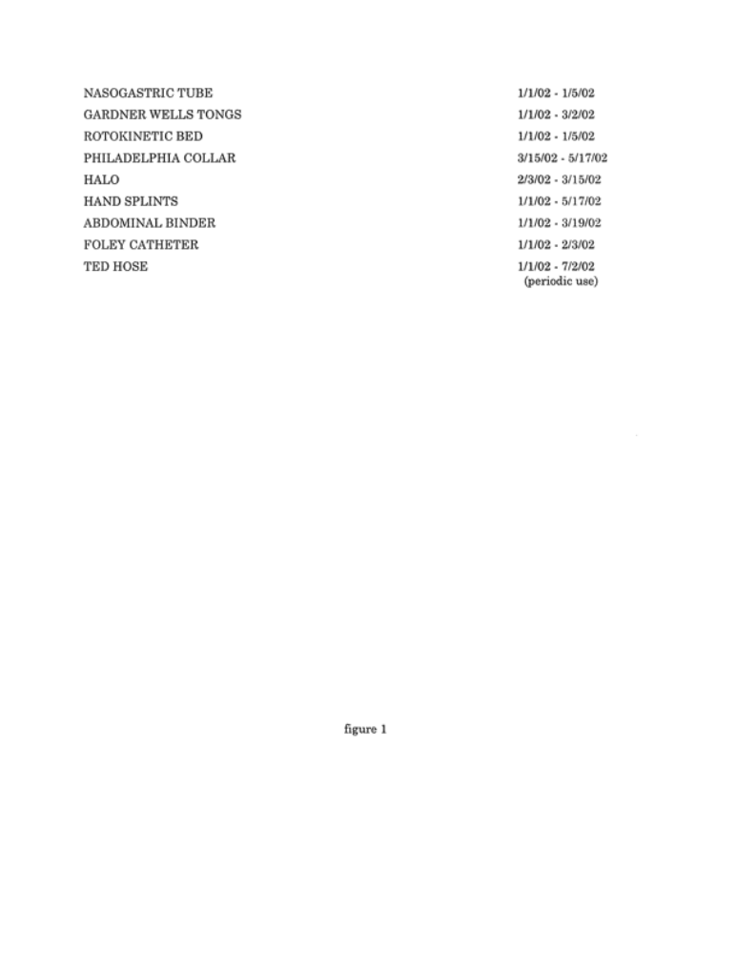

B. (§21.84) Figure 2—Hospital Complications Record

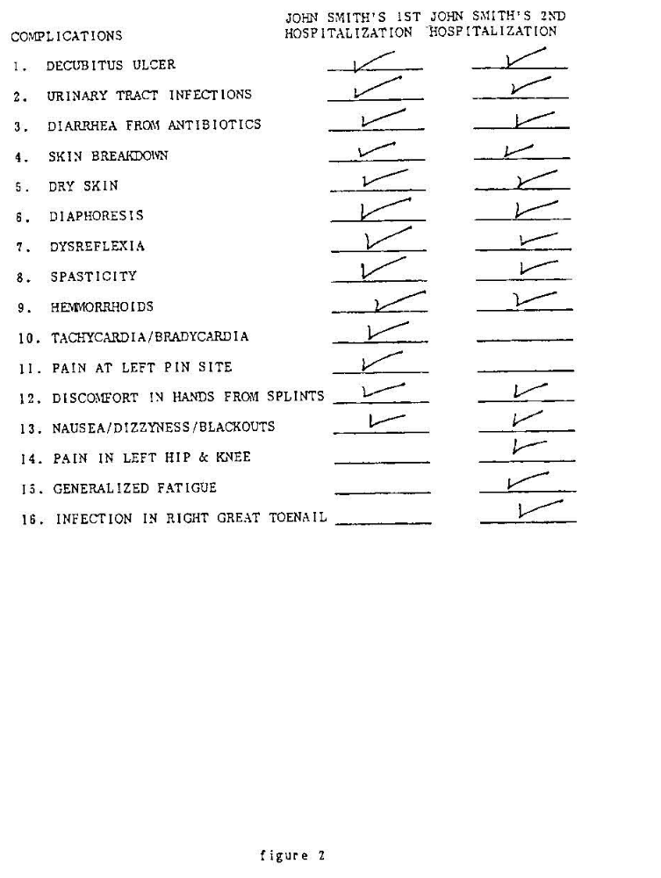

C. (§21.85) Figure 3—Laboratory Tests—John Smith

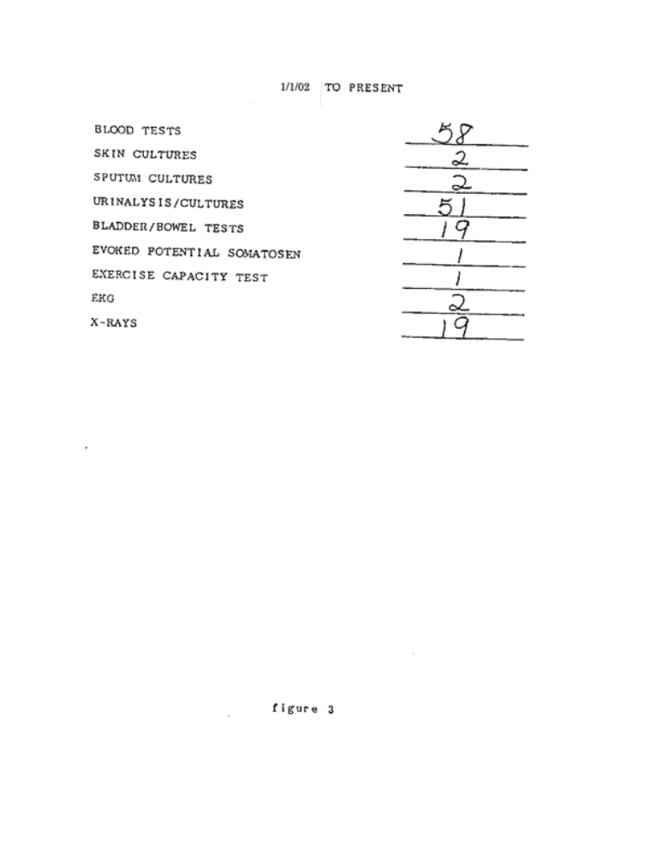
D. (§21.86) Figure 4—John Smith’s Urinary Tract Infections

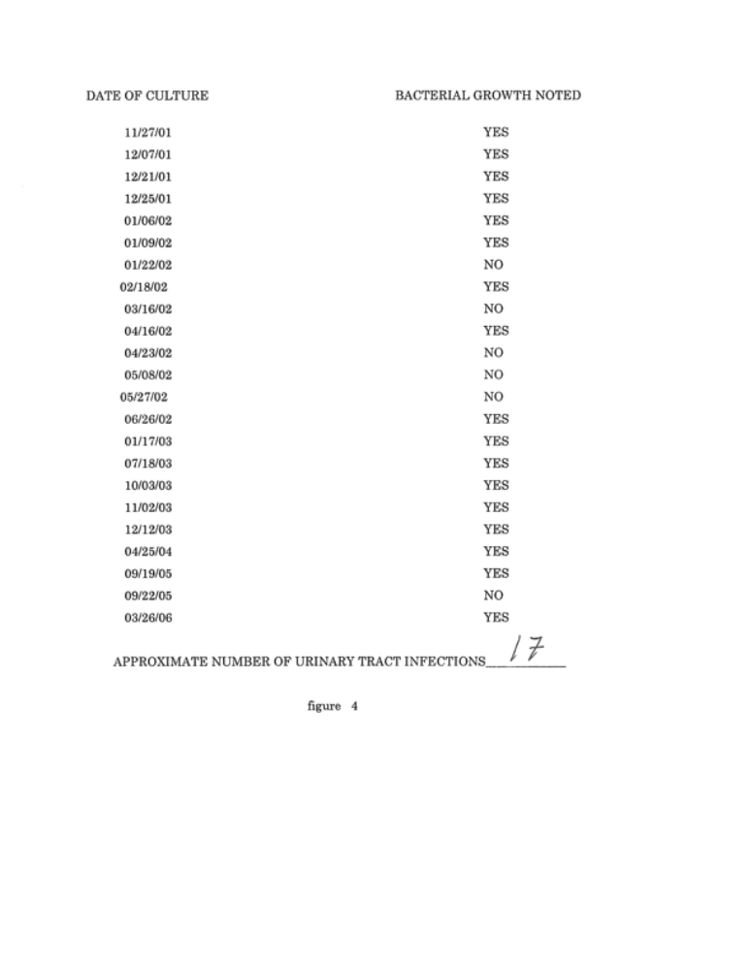

E. (§21.87) Figure 5—John Smith’s Medications
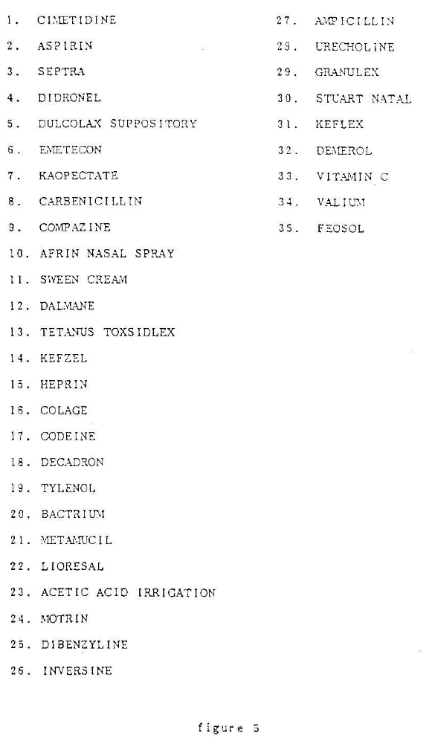

F. (§21.88) Figure 6—Table of Scaled Score Equivalents (1979)

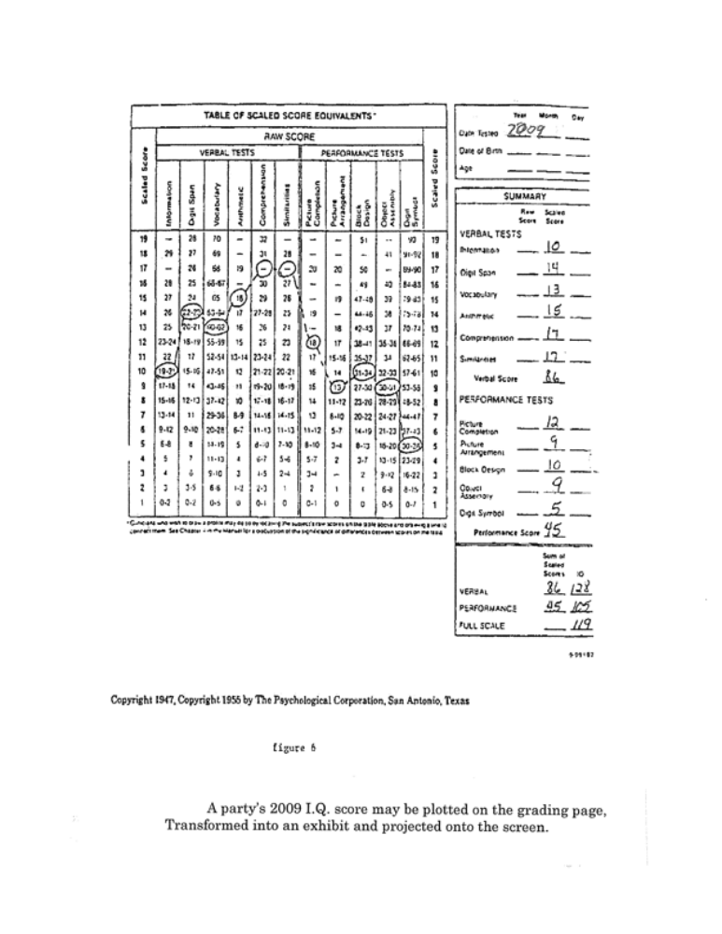

G. (§21.89) Figure 7—Table of Scaled Score Equivalents (1981)

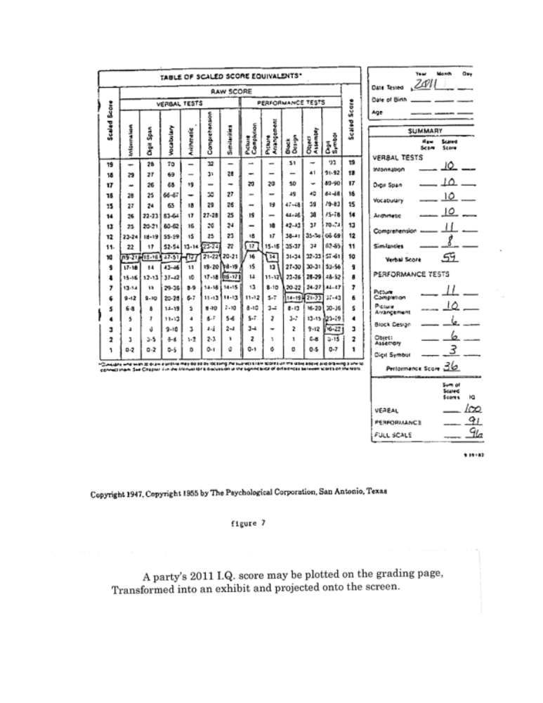
H. (§21.90) Figure 8—Table of Scaled Score Equivalents (Comparison of 1979 and 1981)

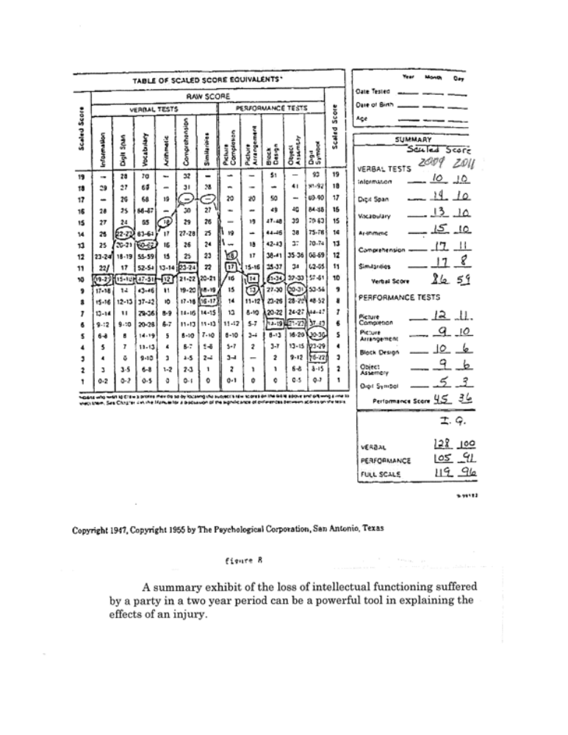

I. (§21.91) Figure 9—John Smith—Vital Statistics

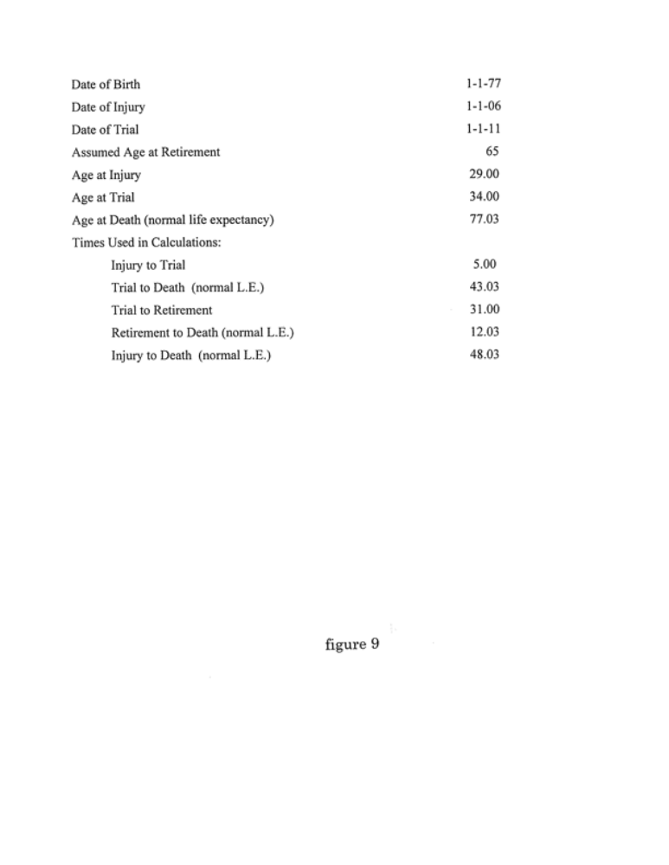

J. (§21.92) Figure 10—John Smith’s Earnings History

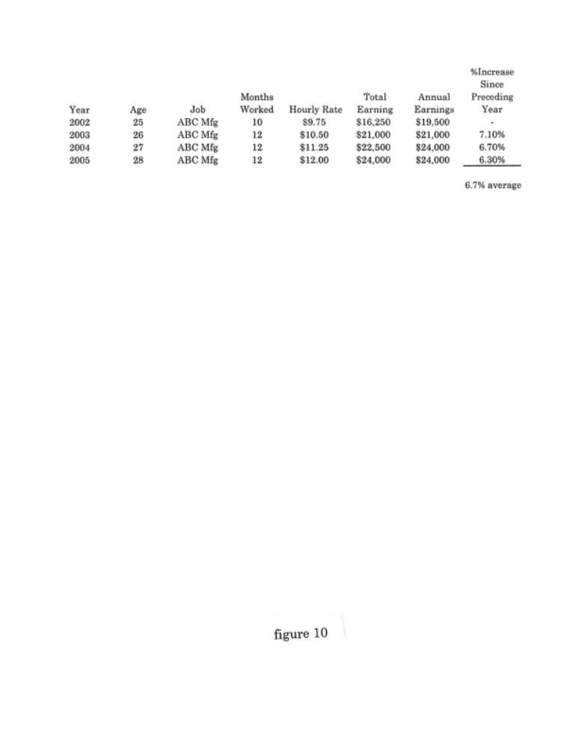
K. (§21.93) Figure 11—Calculation—Past Lost Earnings

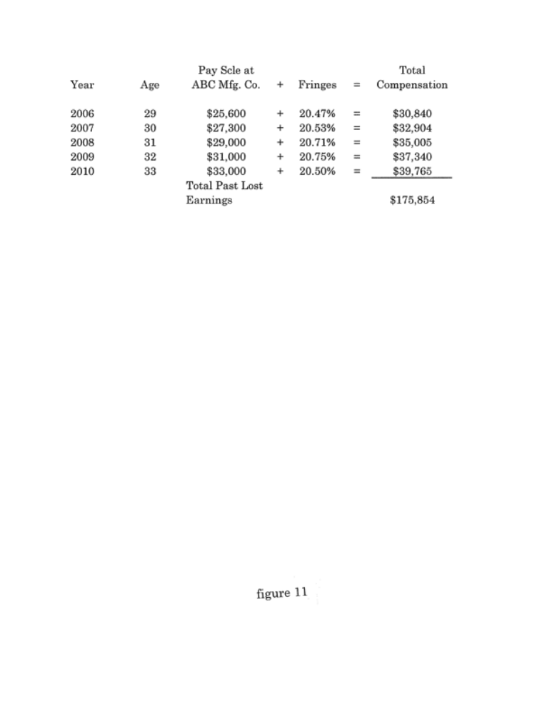

L. (§21.94) Figure 12—United States Historic Growth and Discount Rates

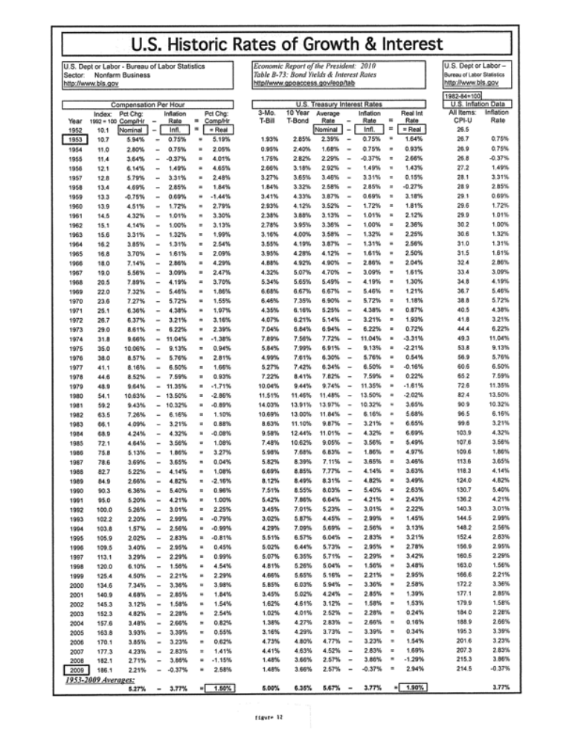
M. (§21.95) Figure 13—Average Earnings—Male High School Graduates*

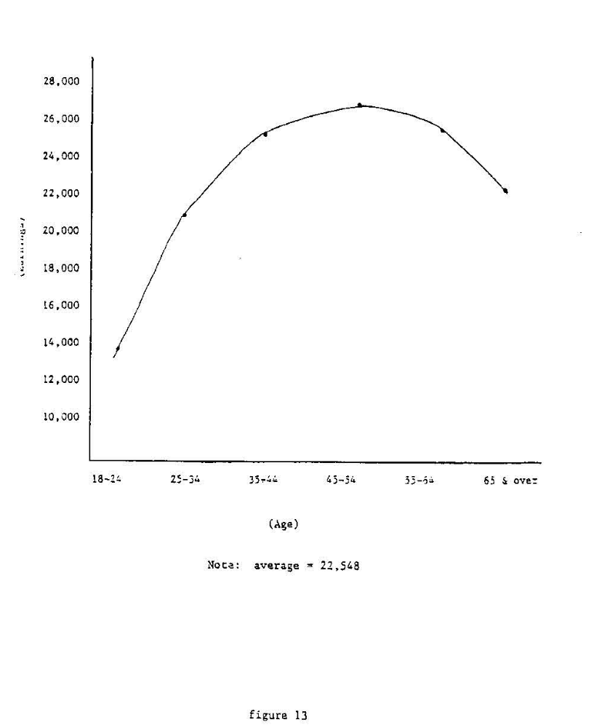

*Value not current

N. (§21.96) Figure 14—Calculation—Future Lost Earnings

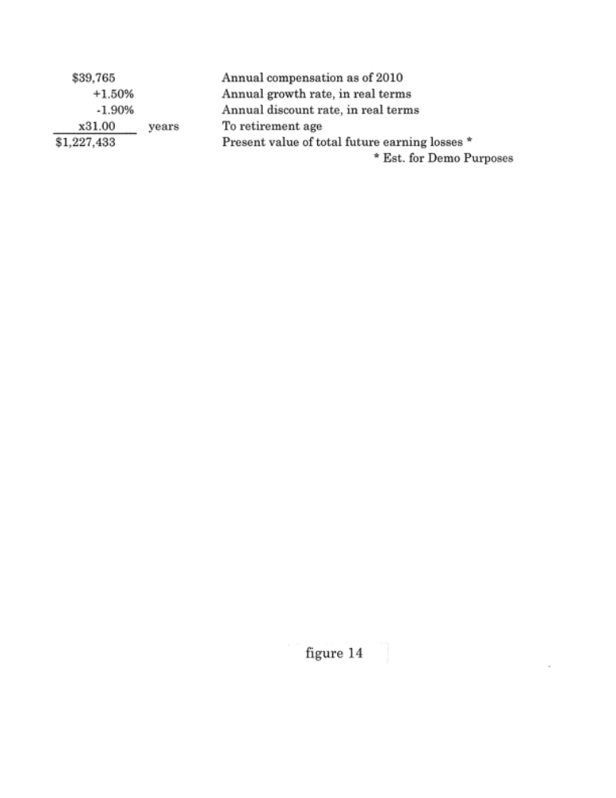

P. (§21.97) Figure 15—Examples of Hourly Costs of Household Contributions

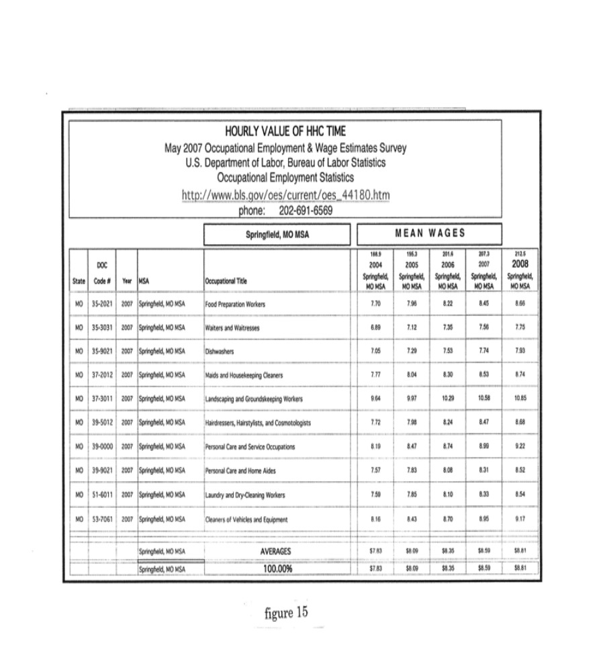
Q. (§21.98) Figure 16—Medical Inflation Rates (1979-2009)

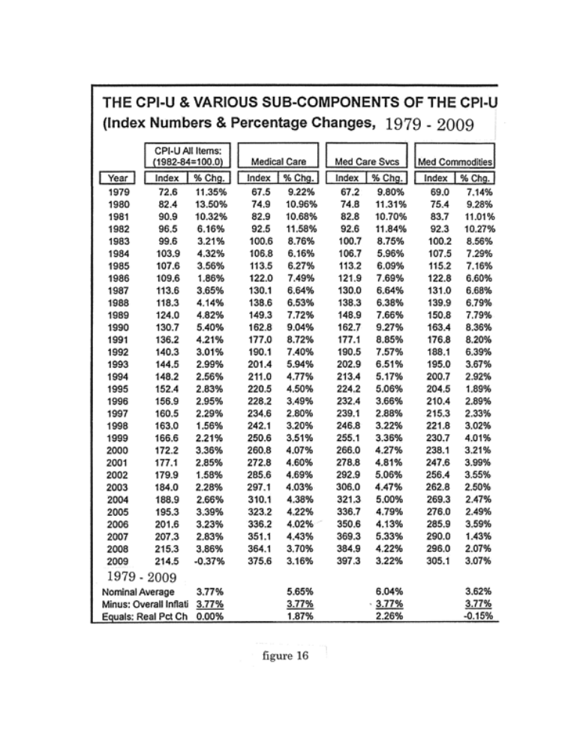

R. (§21.99) Figure 17—Medical Care Calculation

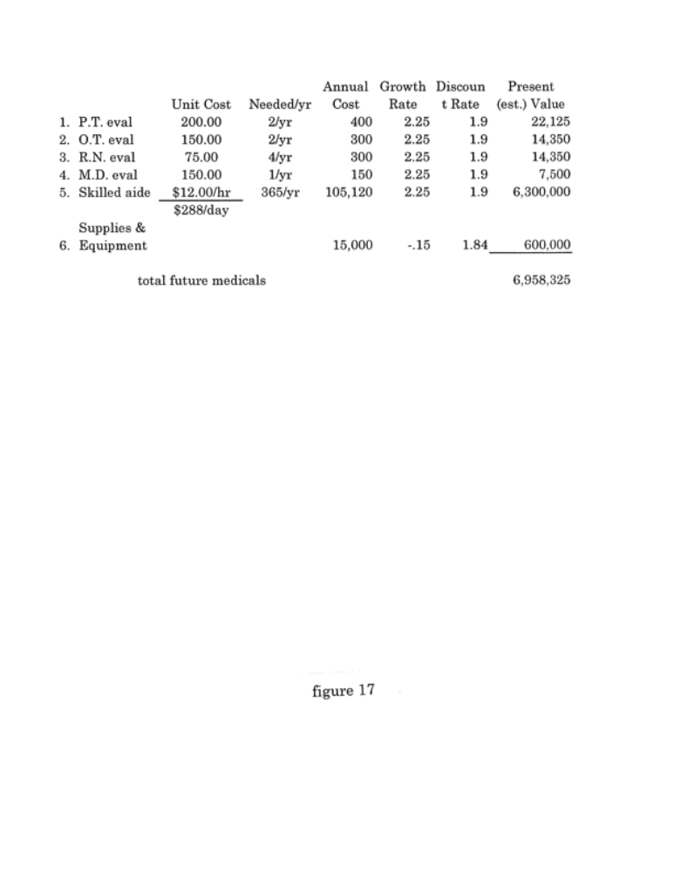

S. (§21.100) Figure 18—Items Not Considered in Calculating

John Smith’s Economic Loss



